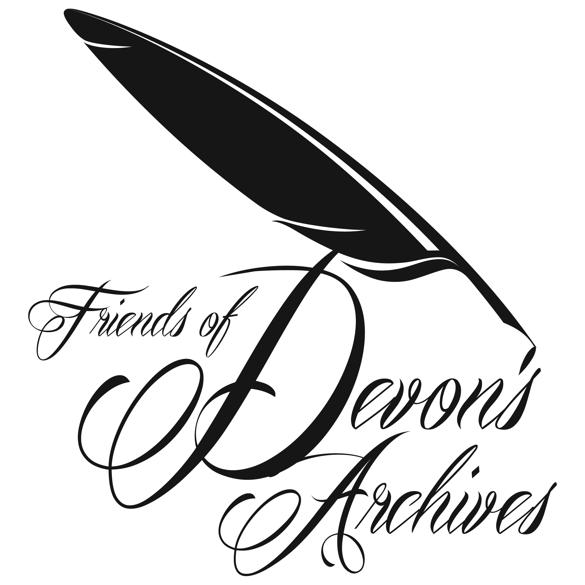

The Friends of Devon’s Archives
www.foda.org.uk
Registered Charity 1107394
c/o Devon Heritage Centre, Great Moor House,
Bittern Road, Sowton Exeter EX2 7NL.

Welcome to the Spring 2022 Newsletter
Belated but warm wishes for the new year. It’s been wonderful to meet in person again and see our archives opening up. This newsletter reports on the fine AGM we held at the Devon Rural Archive and on the remarkable progress made on the Norden Project as well as recent activity of the Devon Bibliography and interesting updates from member institutions. At the AGM we discussed a proposal “To offer dual affiliated membership of DHS and FoDA to local history groups, at a discounted membership rate.” Subsequently Devon History Society came up with a slightly different proposal that as a first step each of us offered a 50% discount to local history groups who were already members of one or other of us. This we are going forward on. Hopefully we will be able to feature some of the work of our local village and town archives in future newsletters. With the expansion of institutional membership FoDA will offer training and support to that membership. I hope you enjoy this newsletter.

Katharine Chant, FoDA Chair

Report on 2021 AGM

REPORT ON FoDA AGM, 4 NOVEMBER 2021

FoDA’s 2021 AGM took place at the Devon Rural Archive, Shilstone House, Modbury, thanks to the able organisation of Abi Gray and DRA staff. Eight members of the Committee and six other Members attended in a well-spaced and ventilated conference room. John Allan was pleased to be able to welcome participants to this face-to-face meeting – the AGM for 2020 having had to go out by Zoom.

The AGM proceeded by confirming the Minutes of November 2020 and Katharine Chant in her Chair’s report spoke about her wish for FoDA’s work to respond to issues of climate change and sustainability, and future proposals about working more closely with Devon History Society. She outlined a grant of £750 donated by FoDA to the Devon and Exeter Medical Heritage Trust for the purchase of documents by the Insane Asylum Exeter - Wonford House Hospital for the Insane, near Exeter, namely: Report of the Committee of Management, 1872-1879, and also Exeter Asylum Reports, Committee of Visitors of Pauper Lunatics, 1886-1890. FoDA also donated £312 to the Devon Heritage Centre towards the purchase of a Kings Book manuscript which is a list of patrons of ecclesiastical benefices in the Diocese of Exeter, with their value in the ‘Kings Books’, a colloquial term for the Valor Ecclesiasticus, compiled during the reign of Henry VIII, although this book is from a much later date. Katharine mentioned the successful Joint DRA/DHS/FoDA Conference held at DRA in September with a talk by Dr Ian Mortimer, The chief rents of Moretonhampstead, 1639-1840: how to use a problematic source.

Katharine paid tribute to John Allan who was standing down as President after many years, likewise to Peter Towey as Membership Secretary, and also to Frances Billinge as Secretary – all hard acts to follow.

Following the Treasurer’s Report by Ian Maxted, and Peter Towey’s Membership Secretary’s Report which had been previously circulated, the Elections to the Committee took place. Katharine Chant indicated her willingness to continue as Chairman for a further year, likewise Ian Maxted as Treasurer, Abi Gray as Programme Officer, and Sue Jackson as Publicity Officer, and Deborah Watson as Committee member. Des Atkinson was appointed to replace David Stone who had regretfully had to give up his work for the Norden Survey. Abi Gray was appointed as Membership Secretary, and Clare Maudling as Secretary and the meeting was informed that Clare will also be taking over the role of administrator for the Norden project as Ros Palmer is resigning.

John Allan also thanked Peter Towey for his many years of sterling work as Membership Secretary which had included digitising membership details and keeping updated on data protection requirements, and Frances Billinge for her efficiency as Secretary over recent years.

Katharine resumed the Chair to thank John Allan for his twelve years of tireless work on behalf of FoDA, and Ian Mortimer, as past chairman praised John for his excellent and aspirational contribution which helped to focus the work of the society. These sentiments were echoed by Brian Carpenter who thanked John for being so willing to attend committee meetings and to help steer the work of FoDA. As to thinking about how to replace John it was noted that this role is not a requirement but it had been extremely helpful to have someone to give advice. As no-one has been proposed for this specialist role, it was agreed to keep the position of President in abeyance at the current time.

There followed a discussion of a Proposal for FoDA and Devon History Society Joint Group Membership with a supporting paper from Abi Gray and Katharine Chant. Its Aim and Purpose was set out with Background Information and a Proposal “To offer dual affiliated membership of DHS and FoDA to local history groups, at a discounted membership rate.” With the expansion of institutional membership FoDA would offer training/support. It was noted that “Abi Gray is the current liaison officer for local groups affiliated to DHS and it is proposed that she should hold a similar role within FoDA. “ It was proposed by Ian Mortimer that the FoDA Committee should explore this joint affiliation further and negotiate a fee which would be acceptable to members and this was seconded and agreed unanimously.

There were two questions raised under Any Other Business: one by Ian Mortimer asking for information on why the Cary project had been turned down by the National Archives and noted that the funding steam was oversubscribed; and another by Debbie Watson who asked for an update on acquisition of the Debenhams’ archive. It was noted that this was headed up by Somerset Heritage Centre who have assisted with storage, with support from the Business Archive Council.

The question of date and venue for the 2022 AGM was discussed and it was agreed that it should be held at a similar time as for 2021 with the possibility of Plymouth as a venue, but noting the difficulty of attracting attendance for any meetings outside Exeter. It was agreed that the FoDA Committee would make appropriate decisions.

The meeting ended and members enjoyed lunch which DRA had laid on. Following lunch and lively chat in a room laid out for the purpose, a tour of Shilstone House and grounds was led by Abi Gray. Those who wished, stayed on for an evening talk by John Allan on Exeter Cathedral.

With thanks to Abi and DRA staff for their welcome and efficiency at what was a very enjoyable day.

Editor

Update from the Membership Secretary

Thank you to everyone who has already paid their membership subscription for 2022, it is great to have you with us again.
For those who haven’t yet renewed, please complete the Banker's Order or Membership form on our website with your name and address and send with a cheque to:
The Membership Secretary, Friends of Devon’s Archives,
Alma Cottage, Western Backway, Kingsbridge, Devon TQ7 1QB.
Membership rates for 2022:
- Individual = £10 per year
- Family (2 people or more at the same address) = £15 per year
- Group, society or other organisation = £20 per year (£10 if a member of Devon History Society)
- Individual life membership = £100.
Membership runs from 1 January to 31 December each year.
If you have any questions about membership, or would prefer to pay by another method, please contact me at the following email address: abigail.gray@acgarchaeology.co.uk

Abi Gray, Membership Secretary, Friends of Devon’s Archives

Plymouth Update

Update from The Box
The last six months at The Box have been extremely eventful. We marked one year of being open to the public on 29 September 2021. Shortly afterwards our outgoing CEO Paul Brookes retired and Victoria Pomery, ex-CEO of Turner Contemporary in Margate joined. We are very lucky to have such an experienced leader to take The Box into its next phase.
Despite having to be closed for six months in our first year, we already have a reputation for our exhibitions and engagement programme and the Songlines exhibition from the National Museum of Australia has had amazing press coverage. Gradually, customers have felt more comfortable physically attending The Box and this has been reflected in all parts of the service. To that end in January 2022 we have increased the opening hours in the Cottonian Research Room to all day on Tuesdays. We have not seen much take-up of the increased opening yet but we are sure that numbers will pick up soon.
Our relationship with the University of Plymouth has gone from strength to strength, too. Whilst in 2020-2021, much of the University's teaching was done remotely, in 2021-2022, all the teaching has been face to face and we have not only hosted this year's cohort of MA in Archival Practice students in the dedicated teaching space: The Foulston Room; we have also hosted a variety of student visits and there are several more booked in over the next few months. The lecturers are requesting access to archives and artworks in tandem and it is really positive to see how much the students are getting out of getting up close to the collections. The vision of The Box to be a centre of excellence for student research is really coming to fruition.
The Media Archive team has also expanded in this period with the addition of two Kickstart Media Assistant placements. These two early career individuals are assisting with everything from scanning and sorting photographic collections to digitising moving image content. They are a huge asset and we have just agreed with the BFI to extend their contracts to the middle of 2022.
We had an initial visit from The National Archives in the autumn and that was extremely positive. Off the back of that we have been invited to put in our Archive Accreditation review paperwork. So much has changed since the previous iteration when we were still in Coxside and we are hoping very much for a successful review given all the range of improvements in collections care.
For those who have not visited recently or who are yet to visit, there have already been substantial changes to the content in Active Archives. Thanks to Archivist Claire Skinner, the stories that are told using the collections are varied and engaging. We are keen to have ideas for the future, however, so please do feel free to make suggestions.
In 2022, we hope to embark on an exciting project to digitise all the watercolours in our collections. There are many thousands at The Box, including within the archive collections. 'Watercolour World' which some of you may know, is on a mission to digitise as many watercolours as possible and host them online here: www.watercolourworld.org. This is a fantastic resource for understanding the changing nature of the landscape and much much more.
If you have any questions or wish to book a visit, please email collections@plymouth.gov.uk.

Louisa Blight, Collections Manager, The Box,
Plymouth City Council, Tavistock Place, Plymouth, PL4 8AX

Dates for your Diary – Forthcoming Conferences

The Icelandic Adventures of Pike Ward of Teignmouth.
An illustrated talk by Katherine Findlay on Thursday, 1st September, 2022 at 7pm in The Devon Rural Archive.
Pike Ward, a fish merchant from Teignmouth, became one of the most important people in Iceland in the late nineteenth century and was a key figure in the birth of the modern nation. He made it possible for Icelanders to escape the virtual enslavement of previous generations and he was much loved. He in turn loved Iceland and stayed for many years, developing a distinctive Devonian-Icelandic identity. In this talk, Katherine Findlay will explore his adventurous life and show how he influenced the trajectory of his adopted country. We will discover the origin of Teignmouth’s famous whalebone arches and learn more about the links between Devon and Iceland.
Katherine Findlay is a writer, researcher and project manager specialising in the history of Devon and Iceland. In 2016 she discovered Pike Ward’s forgotten diaries and photographs and her research into his life resulted in a book about his adventures as well as a series of events and exhibitions in the UK and Iceland. She is a heritage consultant based in Devon and is currently Chair of Devon History Society.
This talk has been organised in association with Devon History Society and Friend’s of Devon’s Archives.
Tickets are £5 each, and must be purchased in advance. To book please visit www.devonruralarchive.com .

2022 FoDA AGM
The 2022 AGM will be a date in November – precise details and venue in the next Newsletter.

SW Heritage Trust Report
Devon Heritage Centre Update
Winter 2021-22

In the second half of 2021 staff adapted well to being open to the public on a regular basis after long periods of closure in both 2020 and early 2021. In 2022 we are approaching the future with optimism and the hope that we can now remain open permanently, allowing us to welcome more researchers but also resume and expand our programme of outreach and engagement work which has been hampered by the pandemic. In early January we hosted the first group tour of the Devon Heritage Centre for two years when we welcomed a group of trainee Exeter Red Coat guides. We plan to expand our events to reach a broad range of people during this year.

We have continued to receive a lot of new archive collections. Over recent months these have included material collected over thirty years by the Branscombe Project, the local history initiative run by the late John Torrance and Barbara Farquharson. This includes original documents, transcripts, local publications, illustrations, photographs and oral history recordings.

Many people will be familiar with the artistic talents of the Reverend John Swete (1752-1821). We hold a collection of seventeen volumes of his journals, but three volumes are missing and were reportedly destroyed during the Second World War. We have recently been sent two watercolours depicting Orestone and the Bishop’s Palace in Paignton by Swete, which apparently originated from one of the missing volumes. This leads us to believe that many of the illustrations from the other journals will be out there somewhere, but who knows where?

In December we purchased a large collection of diaries, albums, watercolours and photographs belonging to the Simpson family of Maypool near Dartmouth. They were bought at an auction in Exeter which attracted national media attention when two 16th century books sold for £365,000, but we paid considerably less!

The conservation staff have also been busy, working on a range of collections including letters from Edward Lear which are held at the Somerset Heritage Centre, the Exeter City ‘Ancient Letters’ and some Japanese watercolours from the Westcountry Studies Library.

Our Project Conservator Lucy Cokes has continued her work on the Probate Accounts of the Diocese of Bath and Wells, another collection from the Somerset Heritage Centre, the work on which has been funded by the National Manuscripts Conservation Trust. Conservation volunteers have been cleaning, packaging, re-boxing and surveying a range of other documents, including deeds from Exeter Cathedral and lantern slides from the Westcountry Studies Library.

In the second half of 2021 we held a series of online and in-person events in connection with our participation in the British Library’s Unlocking Our Sound Heritage project. A virtual event, called ‘A Day in the Life of an Archivist’, took place in November as part of the national Explore Your Archive campaign. Nearly 100 people joined a webinar to hear Esther Hoyle and Brian Carpenter talk about how they became archivists and what the role entails. Those attending came from as far away as Australia. More talks and events are planned for 2022 – keep an eye on our website for details.

A reminiscence DVD produced in connection with the Devon History Society’s Devon in the 1920s project was completed in late 2021 and has now been sent to more than 150 Devon care homes. We hope this will enable residents to enjoy items from our collections and spark memories.

We are grateful for the continued support of the Friends of Devon’s Archives and all its members as we go into a year which we hope will be much calmer and less disrupted than the last two years.

Janet Tall
Head of Archives and Learning
South West Heritage Trust

Brian Carpenter
Community Learning Officer
Devon Archives and Local Studies Service

Norden Survey

NORDEN SURVEY REPORT FOR FEBRUARY 2022 NEWSLETTER
DES ATKINSON

Progress report on the translation process
The Norden Survey comprises 359 pages (or sides) of actual text. The online copy of the survey, available via the London Metropolitan Archives website, describes these as ‘images’. Of those 359 images, our hard-working volunteers have now transcribed and translated 354. I in turn have been reviewing and returning their work, and so far have looked at 235 pages (approximately two-thirds of the total). I expect to complete the rest of that review process by the end of February. We are therefore making good progress against our revised schedule of activities.

The volunteers have wrestled very well with the Latin text, and they have deciphered some quite difficult cursive writing. In doing so they have built up some very useful skills for projects beyond Norden.

Publishing our translation of the survey
We will no longer be publishing the survey as a printed volume with the Devon & Cornwall Record Society. Instead we intend to make a full copy available online. We therefore need to decide exactly what format to use, something that may be determined in part by what system will be hosting it. We need to consider who to approach for hosting – for example should we ask the South West Heritage Trust? Another possibility might be the London Metropolitan Archives since they host the online images.

There may still be scope to produce a limited printed edition through our own efforts at a reasonable cost. That would also allow us to deposit copies with the British Library etc.

Next meeting of volunteers
We had pencilled in a meeting for March 2022 to bring our volunteers back together. It is proposed to meet at the Devon Rural Archive once again. A key topic for discussion will be mapping, and how we proceed for each manor in the survey. After further discussion with Irene Andrews it seems likely we will make use of QGIS as our mapping software. This is a powerful, open-source package that is free to download and use on Windows or Mac systems. The interface is not simple, but some of our volunteers have already started to use it for their own work. We also have a good contact who can assist us further (Martin Smith). We may decide to invest in some hardware that we can share to support that effort. There is still the possibility that we will also contribute to the Know Your Place West of England project (kypwest.org.uk).

Further activities
Our project schedule includes additional activities for us to pursue during 2022. These include talks/presentations within each of the manors of the survey. The possibility of beating the bounds of each manor as described in the survey is something each group of volunteers can ponder. There may be relatively few public rights of way corresponding to the manor boundaries, so permission would need to be sought from the landowners on the ‘circuit of the manor’. We can discuss these items further at the next meeting of volunteers in March.

Des Atkinson

Devon Bibliography

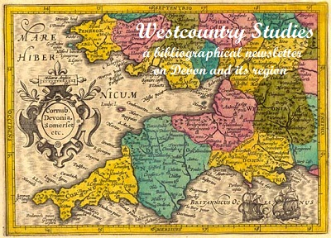 | Westcountry Studies  a bibliographical newsletter  on Devon and its region  Issue 24 draft  February 2022

The previous Devon bibliography newsletter, issue 23, a bumper issue published in December covered five months of developments. For the Spring FODA Newsletter this is an interim update covering the last two months.

Devon bibliography, recent activity
Incorporation of Devon records in the British National Bibliography to the end of 2021 has been completed. The Devon bibliography already holds 55 records for 2022 but, as of 1 February BNB still has not picked up The story of the book in Exeter and Devon received on legal deposit several months ago. It is reassuring to note that as of 1 February there are now 25 Devon publications for 2021 recorded in the SWHT catalogue, including several that had passed the compiler of the Devon bibliography by.

Devon dialect
A new web page has been added to the one compiled for the Unlocking our Sound Heritage initiative, covering periodical and newspaper articles particularly many of the weekly series by Jan Stewer. The dialect database now contains more than 1,800 records for Westcountry dialect, covering also counties adjoining Devon as the dialect continuum does not respect county boundaries.

Newspaper indexes
The historian Peter Christie has generously made available to the Devon bibliography the book section of his massive index to the North Devon Journal from 1827 to 1966. It has more than 4,200 records which are currently being converted from a very long Word file to an Excel spreadsheet with a format which is compatible with the Devon bibliography. It is hoped to add book trade records for the Exeter Flying Post as included in the Exeter Working Papers in Book History Devon book trades directory. Newspaper indexes are still valuable resources for local historians; comment was made in the December newsletter on the shortcomings of the British Newspaper Archive when listing the newspaper dialect articles, largely deriving from the errors generated by OCR. The Exeter Flying Post card index in the Devon Heritage Centre was already compiled in the 1970s in a format that would be susceptible to digitisation, and it covers a wide range of subjects for the period 1763 to 1885 - scope for a funded project to convert it?

Coffinloads of books
Work is in hand transcribing the bookish bits in the manuscript of 68 folio pages by Richard Lapthorne detailing events in London from 1690 to 1699 (2610M/F/2), a transcript of his letters from London to Richard Coffin at at Portledge, Alwington, near Bideford. In 1999 Professor Michael Treadwell was due to visit Exeter to analyse the book related extracts, which had been largely omitted by the published Portledge papers in 1928 but suffered a fatal heart attack on the eve of his departure from Trent University in Canada. Papers relating to his work were passed to me, while the rest of his massive collection of papers on the London book trade of the late 17th century remained at Trent University. I now understand that negotiations are in hand to transfer them to the Bodleian Library, the present home of the British Book Trade Index, so when I have finished transcription I can pass my Treadwell files over. The correspondence provides an unparalleled insight into the workings of the London book trades and its relationship to provincial book collectors in the 17th century.
Letters for 1698 in the recently recognised letter book which are missing from Lapthorne's original letters include some references to the surveyor Norden and the draft transcripts are included here as they link to the FODA project detailed elsewhere in the FODA newsletter. Richard Lapthorne writes from London:
ulto Apr.98
[...] I have a survey by mee of Hertfordshire by Mr Norden don in Qn. Elizabeth's time in a smale print with a mapp its no bigger than a stitched sermon a most accurate [piece ?]. I am informed hee designed to doe every countie in England, but did onely that & Middlesex which two I have by mee & very - much esteem them because wel done & very hard to be gotten, if they are to be [available ?] at all.
2 July -98
[...] as for Nordens 2 little books if I cannot meet with them against your next box, if you please to command mine you shall have them. They are amongst a smale colleccion of odd things which are
catalogued.
[15 October 1698]
[...] I have sent you my 2 bookes of Mr Nordens in which you have He[rtfordshire?] in a nutshell. I hunted up & down in all places where I thought they were to be had but could not meet with either of them at last I was told that Mr Morden (the geographer by the Royal Exchange) had them to whom I applyed, hee had them but they were both put under an old filthy parchment cover & the bookes spotted & steyned abominably & [index ?] wanted the map of Westm. & Hartfordsh. the general map of the county & would not part with it under 4s. so that I have sent my own, the reason why I [was] willing to have bought them was becaus I have a smale collecion of such scarce things & a catalogue of them.
25.8ber.98
Richard Coffin Esqr his account 25. 8ber -98 all former accounts discharged R. L.
[...] Nordens 2 books Middx & Hartfordshire 6s.

Royal Clarence Hotel
In my coverage of the Exeter Literary Festival in the last newsletter I conjured up the vision of the Hotel site becoming the location for an Exeter Literary Heritage Centre, an idea that Darren Marsh, the author of the award-winning history of the Royal Clarence thought would be an excellent idea. We now have proposals for luxury apartments with yet another fine dining opportunity on the ground floor. So ten years after a certain other heritage site departed the city centre leaving behind the Library Lofts in 2012 a further iconic public space could be lost to residents and visitors to Exeter and become luxury apartments that few Exeter citizens can afford.

Ian Maxted

Shakespeare's First Folio : celebrating 400 years

The First Folio edition, which gathered together for the first time the 37 plays that constitute the Shakespearean canon, was published in 1623. Devon Libraries recently restored their copy of the First Folio facsimile under its Adopt a Book initiative. The Royal Shakespeare Company is celebrating the 400th anniversary with a project which recently hit the headlines. Their website announces:

37 Plays is a new national playwriting project led by the RSC and our partner theatres. We are seeking the stories of our times: the comedies, the tragedies and the untold histories. We invite anyone in the UK of any age who would like to write a play to join us over the next 12 months - now is the time to tell your story. The chosen 37 plays will be performed script-in-hand across the UK and online in autumn 2023. Submissions open on 1 January 2023.

FoDA is interested in the idea of Devon celebrating the event in its own way and is working on an idea on the lines of 37 plays for Devon. This would unlock the rich dramatic resources in the Westcountry Studies Library and other libraries in Exeter, not through contemporary plays, but by highlighting Devon dramatic writing through the centuries. Here is a selection of writers that could be celebrated in rough chronological order:

William Shakespeare (the Man Himself includes Westcountry dialect in King Lear), John Ford, Thomas D'Urfey, Nicholas Rowe, John Gay, Hannah Cowley, R.D.Blackmore, Adelaide Phillpotts, Eden Phillpotts, John Galsworthy, Agatha Christie, Jan Stewer, R.F.Delderfield, Ted Hughes.

That's fourteen to be going on with, all of whom are well represented in the Westcountry Studies Library - does anyone have any further suggestions for plays by authors with links to Devon or which are set in the county? Are there any contemporary dramatists? There is certainly someone who is completing the Shakespearean canon with Henry II in blank verse, but he has not yet been contacted. The net could be cast wider: the Cornish Ordinalia for example to the west or Hardy's Dynasts to the east.

Celebrations could include a display of books, talks, even performances of extracts, in collaboration with libraries in Exeter, the Exeter Literary Festival and Exeter City of Literature. The event is certainly too important to be missed in Exeter and the Devon Heritage Centre is sitting on a rich collection of resources, including, beside books, playbills, theatre programmes and illustrations.

Ian Maxted

Other News Items

From Devon Family History Society

Face-to-Face April meeting
Saturday 16 April 1.00-5.30

Two contrasting presentations

The church, sex and slander in Elizabethan North Devon – Peter Christie. Based on a transcript of a court book from the 1570s this talk looks at the 'moral' crimes of our ancestors from some five centuries ago
AND
Early Victorian Farming in Northern Devon: what evidence does the Tithe Survey provide? - John Bradbeer. The North Devon tithe maps, one per parish, were drawn up between 1836 and 1845. They and the accompanying schedules, reveal a great deal about land ownership and land use in the early Victorian era.

Roundswell Community Centre, Gratton Way, Roundswell, Barnstaple EX31 3NL. Plenty of free parking (collect a permit on arrival to stay longer than 2 hours). Regular buses.

Plenty of interesting stalls to browse.

£5 per person, to include tea and coffee. Advance booking required. Bookings will soon be available via our website, or you can send a cheque made payable to ‘Devon Family History Society’, to Tree House, Unit 1, 7-9 King Street, Exeter EX1 1BH

Tree House Research Centre
We have facilities to search all over the world!
King Street, Exeter EX1 1BQ - 10 minutes’ walk from the High Street.

Treehouse is now open regularly each week but if you are coming a long distance, ring for an appointment. We have been enjoying meeting new researchers and welcoming back some of our local regular visitors, it is so nice to catch up with you.

The popular VIRTUAL TREE HOUSE research service and individual Zoom help sessions are continuing. Don’t forget you can contact us, not only by email but by phone or by post. Virtual Tree House is open to all.

Please phone or email us at treehouse@devonfhs.org.uk for all enquiries Tree House, Unit 1, 7-9 King Street, Exeter EX1 1BH. Telephone 01392 433212. Open Monday, Tuesday and Thursday 10.30am to 4.00pm.

Janet Few, Chairman

From Devon History Society

Devon in the 1920s - an update
The project enters a new year this April, and our focus moves on to Progress and Technology. Our first live event takes place on Saturday 23 April at Newton's Place (Newton Abbot Museum) when we look at Devon's 1920s Transport History. This was a time when the railways were at their greatest extent, but were being challenged by the development of the more flexible motor combination of bike, car, lorry and bus. Further details of the event are available at https://www.devonhistorysociety.org.uk/events/spring-conference-on-devons-1920s-transport-history/ . We're also focusing in this strand of work on new housing and on pottery works, craft and industrial.
We continue to populate our map of Devon with family histories, and we are now adding address pins for 'Notable Devonians' nominated by current Devonians. If any FoDA members would like to nominate someone who made a significant contribution to Devon Life during the 1920s, please contact me, j.f.neville@btinternet.com. And do so if you have any other thoughts about Devon in the 1920s or would like to get involved in the research.

Julia Neville

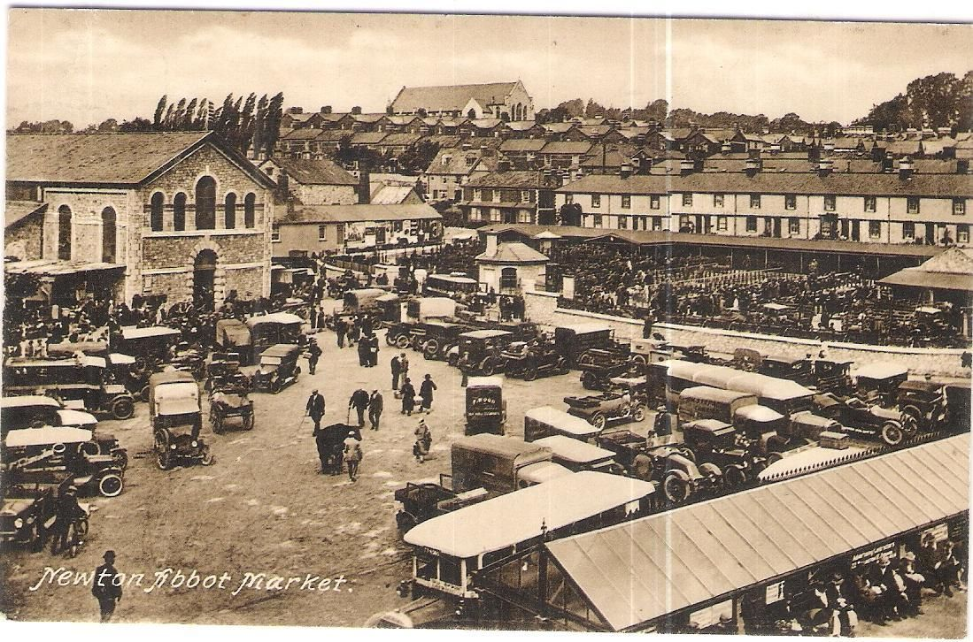

Newton Abbot Market (courtesy Richard Harris).

Accessions & Reports from Archives around Devon

Devon Heritage Centre

DEVON HERITAGE CENTRE EXETER – ACCESSIONS: 24 SEPTEMBER 2021 TO 4 FEBRUARY 2022.

Accession no. | Coll. ref. | Title of  collection | Description of contents | Date Range | Date of deposit | Extent
D2021/129 | ZBBU | Devon Colour Slides | Colour slide transparencies, Lynton and Lynmouth | 1967 | 23-09-2021 | 8 items
D2021/130 | ZBBV | River Dart Boat Trip | Souvenir brochure, with photographs and small map | 1940s-early 1950s | 23-09-2021 | 1 booklet
D2021/131 | 272A | Coldridge Parish | Minutes, Coldridge Parochial Church Council | 1992-2016 | 28-09-2021 | 2 volumes
D2021/132 | 8229D | Exeter Coast and Country Methodist Circuit | Additional records relating to the circuit and its chapels incl. register of deeds and papers, 1705-1994, property registration papers and other records, Exmouth and Budleigh Salterton Methodist churches | 1907-2019 | 29-09-2021 | 1 box, 1 file
D2021/133 | ZBBW | Tony Southern Collection | Print of Honiton Clyst, 1825; booklets on operations at Exeter Airport; research material on Exeter Airport during the second World War. | 1825-21st century | 29-09-2021 | 1 print, 1 binder, 9 booklets
D2021/134 | 4110Z | White Collection | 39th additional deposit to the collection. Includes newspaper cuttings, ephemera relating to Heles School, Old Heleans' Society, various Devon and Exeter events. | 20th century | 07-10-2021 | 5 boxes
D2021/135 | 1618G | Devon Federation of Women's Institutes | Digital copies of reel-to-reel tapes of Devon WI Dialect recordings (1970s) digitised by Unlocking Our Sound Heritage project. | 21st century | 14-10-2021
D2021/136 | ZBBX | Exeter Deed | Bargain and sale, part of premises in Exeter | 1745 | 12-10-2021 | 1 document
D2021/137 | PTC | Peter Thomas Collection | Typed and printed historical guides, guided tour notes, technical information, training course programme and notes, reports, plans, scripts, for training and support of Exeter Red Coat Guides. Includes 'Exetopics' information bulletin 1989- 1992, 'Exeter Redcoat News', 1998-1999. | 20th century | 13-10-2021 | 9 boxes, file of photos
D2021/138 | 6311Z | Devon Record Office Remin-iscences | Addition. Order of Service, funeral of Alice Mary Wells (March 1938-Sept 2021) | 2021 | 15-10-2021 | 1 document
D2021/139 | 6854B | Herbert Read Ltd. | Additional files of documents, mainly correspondence, between Herbert Read Ltd. and its customers, including colour photographs and negatives of ecclesiastical and other wood and stone work done prior to the closure of the firm. Includes files relating to restoration work done at Windsor Castle after the fire, at the Houses of Parliament: House of Commons, and at St. James's Palace. | 20th-21st century | 18-10-2021 | 13 archive boxes
D2021/140 | ZBBY | Devon Tourism | "Geographia" road map of South Devon, 2 miles to 1 in. c. 1940s; Torquay Guide , Exeter Accommodation List & other Information, 1961. | c. 1940-1961 | 19-10-2021 | 2 small volumes, 1 street plan, 2 docs, map.
D2021/141 | ZBBZ | Rousdon Landslip | Postcard titled "The Landslip and Cottage" - Wrench Series No. 3070. | 1909 | 20-10-2021 | 1 item
D2021/142 | 6514Z | Chulmleigh Archive | Addition. Programme, unveiling ceremony for blue plaque, photographer James Ravilious, Chulmleigh, 30 September 2021 by Devon History Society. | 2021 | 25-10-2021 | 1 leaflet
D2021/143 | 5620A | Cadeleigh Parish Meeting | Additional records of the parish meeting - mainly planning papers | c. 2000-2021 | 27-10-2021 | 2 boxes
D2021/144 | ZBCA | Devon Photographs | Postcards, photographs from album of Percy Edward Crick; incl. postcard photographs of floods in Newton Abbot, 4 August 1938 , processions at Buckfast Abbey, for Assumption, 1961 & Corpus Christi 1962. | 1938-1962 | 28-10-2021 | 1 file of 17 photos
D2021/145 | BLA | Blakeway Archive | Additional deposit. Original and copy paintings and drawings of Devon buildings and interior equipment (cider presses etc.), Ordnance Survey map annotated with locations of Devon buildings drawn or painted by Brian Blakeway; photographs, journal publications containing his drawings, digital scans of full DHC archive and material relating to Brian Blakeway now deposited in Royal Engineers Museum Archive. | c.1982-2021 | 03-11-2021 | 1 box, oversize folders, USB stick
D2021/146 | ZBCB | John Kiddey Collection | Press cuttings dealing with Genette Tate case, 1978; digital copy, documentary "The Paper Girl" made by donor for Westcountry Television in 1998. | late 20th century | 03-11-2021 | 1 file, 1 SD card
D2021/147 | ZBCC | Great Western Railway | Agreement, Great Western Railway, use of land at Billacombe Station, Plymstock | 1898 | 09-11-2021 | 1 document
D2021/148 | ZBCD | Exbourne and Jacobstowe Documents | Documents, originals and photocopies, formerly donated to Exbourne Local History Group, mainly relating to local properties in Exbourne parish; maps and plans; farm livestock record with certified calf returns to Exeter, 1948-1949; Rational Association Friendly Society records formerly 1888-1930 (much unfit for production); notebooks, papers, diaries with accounts, William George Coombe of Sand Park, Jacobstowe, builder/ carpenter, 1898-1954 | 1817-1999 | 09-11-2021 | 3 archive boxes
D2021/149 | ZBCE | Dartington Parish Council | Minutes, 1894-2017; declarations of acceptance of office, 1961-1991 with declarations of poll results, 1969-1970, 1973; attendance registers, 1966-1990 handbooks; allotment rentals book, 1935-1987, allotment garden rent counterfoils, 1951-1977 (2), account books, Dartington precept upon rating authority, 1951-1991; insurance policies, 1950s-1960s, correspondence and notes extracted from minute books, 1950-1967. | 1894-2017 | 22-11-2021 | 16 volumes, pt. of archive box
D2021/150 | BOD | Martin Bodman Collection | Research files compiled by the late Martin Bodman of Cullompton, Devon relating to his research in Devon, Somerset and Bristol – railways, mining, shipbuilding, shipping, inclined planes, Quakers;  also prints and copy photographs. | 20th-21st century | 24-11-2021 | 9 ring binder files, 3 bound files, 8 photos, 4 prints
D2021/151 | 4150A | Teignbridge District Council | Six registers of commons and village greens, c. 1967-2012  five files on footpaths in Newton Abbot Urban District Council,1957-1963 Dawlish Urban District Council, 1957, 1950-1963, Teignmouth Urban District Council/ Teignbridge District Council, 1949-1985;  colour Ordnance Survey map of Dartmoor and surrounds, showing contours etc., 1967. | 20th century | 26-11-2021 | 6 volumes, 5 files, 1 map
D2021/152 | ZBCF | Dr. Alick Cameron Collection | Research notes, copy photographs, negatives, colour slide transparencies, overhead transparency sheets, photocopies and papers on the history of medicine and medical personnel |  | 26-11-2021 | 2 archive boxes
D2021/153 | DRP | Devon Remembers First World War Collection | Additional deposit. 'Provincial Patriots' - film of play written and performed by The Plough Youth Theatre, Torrington, as part of the Devon Remembers project | 2018 | 22-10-2021 | 1 digital file
D2021/154 | ZBCG | Northernhay Club, Exeter | Visitors' book recording date, name of visitor, length of stay, normal residence, signature of member by whom they were introduced. | 1876-1923 | 01-12-2021 | 1 volume
D2021/155 | ZBCH | Publications and Reports | ‘Travellers Making Connexions: a good practice guide for multi-agency work’, Connexions Cornwall and Devon; ‘Progress in Partnership: strategy for mental health, learning disability and substance misuse services 2006-2009’, Devon Partnership NHS Trust; ‘Access to dental services in the south west’, joint councils report | 2004-2005 | 02122021 | 3 volumes
D2021/156 | ZBCI | Devon Slides | Large collection of colour slide transparencies, mostly indexed or listed, relating to Devon [those of other counties & places are being weeded from deposit] | 20th century | 20-03-2020
D2021/157 | 2901A | Holsworthy Parish | Minutes, Easter Vestry with AGM Parochial Church Councils, 1976-2004, Parochial Church Council, 1986- 2004, booklet, Christian Stewardship Campaign, 1966. | 1966-2004 | 07-12-2021 | 3 volumes
D2021/158 | 3326A | Exbourne Parish | Poor rate assessments, 1883- 1884, 1925; copy of abstract of rateable hereditaments 1934. | 1883-1934 | 09-11-2021 | 3 volumes
D2021/159 | 4084A | Jacobstowe Parish | Poor rate assessments | 1925 | 09-11-2021 | 2 volumes
D2021/160 | DBD | Devon Birds | Second additional deposit to collection incl. Reserve Management Plan, Bird Surveys, Lundy Field Society Annual Report, 2015, transcriptions of earliest society magazines (1946), four discs of photographs | 1996-2016 | 08-12-2021 | 6 documents, 4 CD-Rom discs
D2021/161 | VIC | Vickery Collection | Photographic record of listed buildings in south and east Devon, photographed by volunteer for the English Heritage website 'Images of England'; c. 900 35 mm colour photographic prints and negatives organised in files with Listing Sheets, film recording sheets, omissions and errors sheets for buildings not photographed.  Explanatory papers, Volunteer Photographer's Manual, 2006. | 1999-2006 | 08-12-2021 | 3 archive boxes
D2021/162 | 2399D | Devon and Dorset Mission (later Sidmouth and Bridport Methodist Circuit) | Minutes, Sunday School teachers' meetings, Honiton Methodist Church, 1917-1943, few photos, 1933 - c. 1960s. | 1917-c.1960s | 09-12-2021 | 1 volume, photos
D2021/163 | ZBCJ | Devon Inn Signs | Black and white photographic slide transparencies of inn and public house signs in Devon (and elsewhere ) | 1959-1964 | 09-12-2021 | 1 small box, c. 200 slides
D2021/164 | TUC | Tucker, Solicitor of Ashburton | 3rd additional accession of title deeds, leases, wills, correspondence and other papers, incl. properties in Widecombe in the Moor & Manaton & houses in Plymouth. Also papers, William Bernard, deceased re land grant, South Australia, 1842-1886. | 1842-1899 | 09-12-2021 | c. 80 documents (0.5 box)
D2021/165 | ZBCK | Johns and Needs Families | Research on Johns family {c.1740s-1930) and Needs family (c. 1720s-c. 1900) of Devon and Somerset, and related families. Includes pedigrees, family group sheets and narratives. | 1980s-2021 | 09-12-2021 | 2 folders, 1 disc
D2021/166 | ZBCL | Past Rotarians Association | Minutes, 1980-2008, Exmouth Past Rotarians Club | 1980-2008 | 10-12-2021 | 0.75 box
D2021/167 | 6333G | Inner Wheel Clubs, Devon | 12th additional deposit Minutes, club and committee, 1930-2018, Exmouth Inner Wheel Club. | 1930-2018 | 10-12-2021 | 1.5 boxes, 6 volumes
D2021/168 | 874D | Society of Friends | 14th additional deposit. Minutes, various Devon Area Meetings & local meetings in Devon | 1985-2019 | 10-12-2021 | 2 boxes
D2021/169 | 3824Z | Apprentice-ship Indenture | Private apprentice John Stark, bound to Richard Granger and Son of Whimple, in masonry | 1867 | 13-12-2021 | 1 document
D2021/170 | ZBCM | Swete Watercolour Sketches | Two watercolour sketches by the Reverend John Swete (born 1752, died 1821) June 1793 - Orestone view, and ruins, Bishop's Palace at Paignton. | 1793 | 30-11-2021 | 2 sketches (on front and back of single sheet)
D2021/171 | ZBCN | George Beer Diary | Notebook diary, George Beer of Aveton Gifford. Includes records of bell-ringing, Queen Victoria's Jubilee celebrations at Aveton Gifford,21 June 1887, story in Devon dialect describing the agricultural show in Exeter. | 1887 | 14-12-2021 | 1 small volume
D2021/172 | 7186A | Cowley Chapel | Register of Services | 2010-2011 | 14-12-2021 | 1 volume
D2021/173 | BRP | Branscombe Project | Records collected over 30 years during the life of the Branscombe Project. Includes original documents, transcripts, local village publications, prints and drawings, photographs and photograph albums, scrapbooks, exhibition folders, newspaper cuttings, oral history recordings, digital images, talks. Includes material in various formats on M.S.C. Napoli disaster. | late 19th century-21st century | 13-12-2021 | 15 large file boxes; 12 box files (c. 30 archive boxes)
D2021/174 | QS | Devon Quarter Sessions | Additional Devon County Quarter Sessions papers, including constables' presentments, jury lists and lists of freeholders, 1599-1792, constables' certificates regarding health of horned cattle, 1747, land tax assessments, 1790-1792, accounts and receipts, various other papers. | 16-19 cents | 09-12-2021 | 1 box

Accession no. | Coll. ref. | Title of  collection | Description of contents | Date Range | Date of deposit | Extent
D2022/1 | ZBCO | Simpson Collection | Records of the Simpson family formerly of Maypool near Dartmouth, including diaries, Francis Russell Benedict Simpson and Edith Mary Simpson nee Seale c. 1898-1957; sketch books, albums, loose watercolours, prints, programmes, photographs | 19th-20th century | 15-12-2021 | 3 boxes
D2022/2 | ZBCP | Arnold Clare Collection | Lectures and articles by Arnold Clare, (1901-1991) medium, priest, healer and exorcist, Torquay Theosophical Society member, priest, Liberal Catholic Church. | c. 1950s-1970s | 01-12-2021 | 0.75 box
D2022/3 | ZBCQ | Bibbings of Wolborough | Papers, cashbook, estates of George Bibbings, Aqua Villa, Wolborough, 1886-1897,and Eliza Grace Bibbings, 1898; photographs, family group on holiday c. 1930s, photograph, group of men and women, c. 1940s. | 19th-20th century | 11-01-2021 | 2 files
D2022/4 | ZBCS | Hemyock Wesleyan Chapel | Non-conformist meeting house certificate, May 1828, note on Benjamin Wood and family. | 1828-c.2021 | 12-01-2022 | 2 items
D2022/5 | ZBCR | Cockington Court, Torquay | Reports, notes, drawings, photographs, Cockington Court archaeological investigations | 2010 | 11-01-2022 | 1 large file
D2022/6 | ZBCT | Diptford Deeds | Deeds relating to properties in Diptford, including Broadmead, Northcombe and Court Farms. | 17th-19th century | 17-01-2022 | 1 box
D2022/7 | 6742A | Feniton, Buckerell and Escot Parishes | Additional parish magazines, Feniton and Buckerell - then titled "The Country Churchman". | 1962-1972 | 18-01-2022 | 1 bundle
D2022/8 | 8749Z | Devon Wills | Additional deposit of copy wills and testamentary papers | 1794-1865 | 18-01-2022 | 1 bundle
D2022/9 | ZBCU | Lockyer Family | Family history research notes, family trees, research correspondence, news cuttings, photographs, Lockyer family of Withycombe Raleigh, Woodbury, Branscombe, and Ealing, London. | 20th-21st century | 18-01-2022 | 2 files
D2022/10 | 2473Z | Dunkeswell Abbey | Additional deposit – orig. drawings of stained glass windows, 19th century, 22 files and 5 albums containing copies of deeds, copy extracts, notes, copy and original correspondence, copy illustrations, sketches, photographs, plans, Dunkeswell Abbey and Dunkeswell Abbey Preservation Trust, the Simcoe family, Wolford Chapel, the conventual church, Sheldon Church and Parish, and Forde Abbey. | 19th-20th century | 21-01-2022 | 1 oversize file; c. 4 archive boxes
D2022/11 | 2518A | Wolborough Parish | Wolborough parish magazines – addition to parish collection | 2003-2005 | 24-01-2022 | 3 bundles

Kindly supplied by Jan Wood, Devon Heritage Centre

North Devon Record Office

Collections accessioned 1 September 2021 to 25 January 2022

ND/2021/29 | 2316C | Shirwell School anniversary - speech by Headmaster | c.1980 | 09/09/2021 | 1 Audio cassette
ND/2021/30 | B955 | Appledore Book Festival programme | 2021 | 09/09/2021 | 1 booklet
ND/2021/31 | B1441 | Barnstaple Baths and Washhouses Company Ltd. Account book with lists of subscribers and inventory of goods and books | 1862-1882 | 10/09/2021 | 1 volume
ND/2021/32 | B1105 | Barnstaple Longbridge Townswomens’ Guild: minutes and reports | 2001-2020 | 10/09/2021 | 3 volumes,  1 bundle
ND/2021/33 | 1892A | Parrkham Parish: Highway rate books | 1846-1859 | 14/09/2021 | 7 volumes
ND/2021/34 | 697C | Peters Marland School: plans and letters re new classroom and offices | 1909-1910 | 16/09/2021 | 1 plan,  3 letters
ND/2021/35 | 2926D | Bude Methodist Circuit: Women's Missionary Work Minute Book, 1934-1965; Women's Network Minute Book, 1975-2009; Wednesday Fellowship Minute Book, 1995-2016;  Stratton Methodist Church: Council Minutes, 1985-2017; Bush Methodist Church: Sunday School Minute Book, 1899-1956; Minute Books, 1949-1986; Pamphlets, 1952 & 1969; Cradle Roll; Church Centenary Celebration Poster;  Launcells Methodist Church: Cash Book, 1937-1995; Pulpit Notice Books 1961-1988; Minute Book, 1968-2020;  Pamphlets and Assorted Photographs, 1902-1962; plan of new schoolroom, 1974; Poughill Methodist Church: Minute Books, 1914-2005; Account Books, 1924-1998; Rechabites Dispensation poster; Cradle Roll. | 1887-2020 | 18/09/2021 | 1 box,  1 bundle
ND/2021/36 | B1442 | Horwood House: Door plan and photographs of renovations | 1950s-1960s | 16/09/2021 | 1 plan,  2 photographs
ND/2021/37 | B822 | North Devon Ramblers: maps, plans, correspondence and videos etc. regarding work on footpaths | 20th cent. | 23/09/2021 | 6 boxes
ND/2021/38 | B387 | Chumleigh Deanery Magazine | 1889-1895 | 20/10/2021 | 1 volume
ND/2021/39 | B1443 | Bideford Harbour: Shipping registers; Harbour undertakings; wages book, bills of entry. | 1958-2006 | 06/10/2021 | 6 volumes
ND/2021/40 | B663 | Instow, Westleigh and West Yelland Parish News magazine | 2019 | 06/10/2021 | 11 booklets
ND/2021/41 | B1445 | North Devon Conservation and Civic Society: correspondence, certificates etc. | 1980s-2000s | 06/10/2021 | 5 boxes
ND/2021/42 | B1124 | North Devon Maritime Museum: booklet celebrating the first 21 years | 1998 | 20/10/2021 | 1 booklet
ND/2021/43 | B1444 | Barnstaple Boys Secondary Modern School: The Artivian magazine, vol 2 | 1950 | 20/10/2021 | 1 booklet
ND/2021/44 | B1188 | Buckland Brewer School: Flying Start Federation documents | 1955-2014 | 07/10/2021 | 3 boxes
ND/2021/45 | 2976A | Alverdiscott Parish: Register of marriage | 1994-2021 | 03/11/2021 | 1 volume
ND/2021/46 | 1562A | Atherington Parish: Register of marriage | 1973-2021 | 03/11/2021 | 1 volume
ND/2021/47 | 2215A | Beaford Parish: Registers of marriage | 1990-2021 | 03/11/2021 | 2 volumes
ND/2021/48 | B264 | High Bickington Parish: Registers of marriage | 2007-2021 | 03/11/2021 | 3 volumes
ND/2021/49 | 2977A | Horwood Parish: Registers of marriage | 2001-2021 | 03/11/2021 | 2 volumes
ND/2021/50 | 2954A | Huntshaw Parish: Register of marriage | 1998-2021 | 03/11/2021 | 1 volume
ND/2021/51 | 2978A | Newton Tracey Parish: Register of marriage | 1980-2021 | 03/11/2021 | 1 volume
ND/2021/52 | 2216A | Roborough Parish: Register of marriage | 1995-2020 | 03/11/2021 | 1 volume
ND/2021/53 | 2180A | St. Giles-in-the-Wood: Registers of marriage | 1995-2021 | 03/11/2021 | 3 volumes
ND/2021/54 | 2288A | Tawstock Parish: Registers of marriage | 2009-2021 | 03/11/2021 | 5 volumes
ND/2021/55 | 2979A | Yarnscombe Parish: Register of marriage | 2004-2021 | 03/11/2021 | 1 volume
ND/2021/56 | B1443 | Bideford Harbour Master’s Report Book | 1930-1943 | 18/11/2021 | 1 volume
ND/2021/57 | B1446 | Bratton Fleming History Archive: Maps, copy articles, conveyances, sales particulars, photographs and ephemera | 19th-21st cent. | 18/11/2021 | 1 box,  2 bundles
ND/2021/58 | 2288A | Tawstock Parish magazines | 1894-1903 | 23/11/2021 | 1 volume
ND/2021/59 | B1447 | Lynmouth title deeds | 1892-2002 | 08/12/2021 | 1 bundle
ND/2021/60 | B1448 | Barnstaple Gas Works plan | 2004 | 22/12/2021 | 1 plan
ND/2021/61 | 3978 | Northam Urban District Council: Defence Committee minutes; Book of Signatures; Correspondence; Receipts: Day Book; Accounts; Appledore Draft Local Defence Plan; ARP Guidance; consolidated Instructions to Invasion Committees; bundle of local election ephemera including polling station posters and campaign leaflets | 1941-2021 | 15/12/2021 | 4 volumes,  2 bundles
ND/2022/01 | B186 | Devon Cattle Breeder’s Society: Davy’s Devon Herd Book | 2020 | 14/01/2022 | 1 volume
ND/2022/02 | B1449 | Abstracts of title, conveyances and property search papers re Glenover, Abbotsham Road, Bideford and Venton Farm, Westward Ho! | 1908-2000 | 13/01/2022 | 1 bundle

Kindly supplied by Gary Knaggs, North Devon Heritage Officer, North Devon Record Office

THE BOX

4334: Visitors' books for the Elizabethan House, 32 New Street, Plymouth. 1930-1948.

4335: Freemasons, Lodge of St John no.70, Plymouth, Book of constitutions; Lodge of Instruction minutes; regular meeting minutes; attendance books; bylaws books; declarations books; returns books; bylaws signature books; books of summons and petitions; treasurer's book; membership registers; programmes, menus and miscellaneous documents. 1815-2012.

4336: Claude Medhurst of Devonport, lay preacher. Notebook including details on the uses of plants and herbs for medicinal purposes and recipes for preparing and cooking food and also drinks. Late 19th century.

4337: Keyham memorials' archive. Notes, letters and cards originally associated with flowers and objects donated by individuals and organisations in response to the shootings in Keyham of Maxine Davison, Lee Martyn, Sophie Martyn, Kate Shepherd and Stephen Washington, on 12th August 2021.

4338: Books of condolence, and a leaflet relating to the Keyham shootings. 12 August 2021

4339: Manuscript history of the Plymouth Forum 1968-1975, bound into a volume also containing a list of members, letters, monthly bulletins, photographs, newspaper cuttings, annual programmes etc. Compiled by C John Littlefield, President of the Forum in 1982-1985. 1968-1975.

4340: Bradford family of Plymouth photograph albums and journal Albums (3), 19th-20th cent including Bradford family photographs plus journal of John Henry Russell Bradford, on board HMS Calcutta and HMS Centurion, 1850s.

4341: Freemasons, Lodge of Integrity No 4098 of Plymouth. Minute books 1920-1995; summons to meetings 1920-1929, plus 1960-1984; attendance registers 1920-1934 and 1942-1978.

4342: Papers relating to the 250th anniversary of St Aubyn's Chapel, Devonport, comprising: a transcript by E T Young in 2021 of Rev Blackett's consecration sermon, 1771 and the riposte by G Keith and J Johnson, 1772; an invitation and an order of service for the anniversary service 19 Sep 2021; and a poster advertising the exhibition and other events for the anniversary, Sep 2021.

4343: Coxside Cartographies: published brochure and postcard of a 'Coxside Cuppa' ceramic work. 2020.

4344: Diary of G Winne [Wynne] of Plymouth, mentioning his godfather the Duke of Clarence, afterwards William IV, 1787-1790, with copies of letters, 1891-1897 at the rear, with transcript. Winne was the father of Mary Hawker, wife of Lieut Col John Hawker of Plymouth. 1787-1897.

4345: King family of Plymouth: books and family history notes including Jewitt's History of Plymouth, 1873; Worth history of Plymouth 1890; Kelly's Directories of Plymouth, 1937 and 1955; Kelly's Directories of Devonshire, 1906 and 1939; copy photograph of the Plymouth Co-operative, early 20th cent; notes on the Zanazzi family of Plymouth, 2007; family tree of King family, 2010.

4346: H S Saughton & Partners, Quantity Surveyors, Plymouth, bills of quantities Bills of quantities for various Plymouth civic buildings including the Guildhall plus a public house, Plymouth. 1935-1959.

4347: Plymouth, Efford Cemetery, Crematorium registers, noting date of cremation, name and former residence of the deceased, age and sex, date of death, with the name and address of the person applying for cremation, the names and addresses of the persons signing the certificates, registration district, name of funeral director, and how the ashes of the deceased were disposed of, 18 July 1953-18 November 1993; duplicate deed registers for burials, 8 May 1924-23 December 1965; loose duplicate burial deeds, 28 December 1967-27 January 1976. [For cremations from 16 November 1934-18 July 1953 see Accession 4120].

4348: Plymouth, Weston Mill Cemetery, Cremation registers, noting date of cremation, name and former residence of the deceased, age and sex, date of death, with the name and address of the person applying for cremation, the names and addresses of the persons signing the certificates, registration district, name of funeral director, and how the ashes of the deceased were disposed of, 1 March 1967-23 July 1996. Also duplicate grave deed certificates, from certificate number 7530-12000, dated circa 1975-12 March 1998. ś śAlso registers of purchased graves, circa 1964-1 Dec 1994 (with gaps), with details of the location of the grave, payment by named purchaser with their address and number of the grave on the cemetery plan, 28 February 1905. ś[For Weston Mill burial registers for 24 November 1904-27 February 1998 please see Accession 4120].

4349: Plymouth Argyle Football Team, Programme Programme for football match between West Ham United and Plymouth Argyle, with list of the players. 16 Feb 1946.

4350: Memoir of Harold Frederick Williams of Keyham, Plymouth, (1924-1996) The memoir was mainly written c1980 with additions by Harold's sons in the late 2000s. It mainly concerns the period from Harold's earliest memories of the 1920s through to 1938, with a few references to post-war events. śWilliams and his family lived at no 3 Cotehele Avenue for the first ten years of his life; he recalls businesses such as Mr Hobbs the baker, Mr Vosper the shoe-repairer, and Mr Reep's the butchers on College Road. He describes horse-drawn transport, trams, and railways; excursions to Bovisand, Wembury or Whitstands Bay; a charabanc trip to Antony; and a holiday in Bere Ferrers. He discusses childhood games and being a choirboy at St George's Road Methodist Church; the Warner family who shared a pew; and the choir master Mr Minhinnick. (pp5-6). śHe then describes school (College Road Infants' p8 and Ford School, p9). He describes going to the pictures at the Ford Palladium (p10). He then discusses family history (pp11-12) and the early life of his father. c1980-2000s.

4351: Plymouth Barnardo's. Cutting advertising a summer holiday playscheme provided by Barnardo's together with Social Work students and volunteers in St Aubyn's, Plymouth. The playscheme was the first of its kind in Plymouth. The donor is a former social work student and worker for Barnardo's. 1973.

4352: Illustrated London News article about the opening of the Royal Botanic Gardens, Plymouth, 3 Aug 1850.

4353: Mayflower 400 Copy of a commemorative scroll presented by the UK Houses of Parliament to the US House of Representatives, produced by Thames Alive and presented to the Mayor of Plymouth, then transferred to The Box, with associated leaflets. 2020.

4354: Papers of William Willis, Manager of the Palace Theatre, Plymouth Including copies of reviews by Willis, 1948-1955; and a folder of photographs, letters, posters and programmes compiled by Willis, including copies of letters from Laurel and Hardy and other performers, 1946-1956.

4355: Book of condolences for the families and friends of the victims of the Keyham shootings, compiled by the congregation and community of St Pancras Church, Pennycross. The Keyham shootings took place 12 August 2021 and the book was compiled in the two weeks following that event. See also 4338 for other books compiled by Plymouth City Council and others. 2021.

4356: Sargent family photographs and papers - Bill from Ernest Smith, surgeon, for attending J J Sargent Esq, 1907; Corporation Grammar School bill, 1930; family photographs, late 19th-early 20th cent; school group photographs, early 20th cent; Westward TV programme guide "This is Our Land", 1968; TRAC record no 5, 1982.

4357: South Devon Railway, Sutton Harbour Branch, plans of bridges built along the branch line showing details of the construction of each bridge. 18 Sep 1874-Oct 1877.

4358: Article about Sophia Elau of Vanuatu, who died in Plymouth in 1834, from Journal of Pacific History by L Lindstrom, 1998.

4359: Photographs and copies of documents relating to Dr Alison Jean Jesson, nee McNairn. Dr McNairn was recipient of the George Medal for bravery during the Blitz for her work at Plymouth Children's Hospital. [1941-1999].

4360: Henry Lawrence Spear and family of Plymouth. Scrapbook of Henry Lawrence Spear when deputy Mayor, 1945-6; press photographs including H L Spear, 1934-1956; illuminated presentation to Maud Spear 1970s; photo of William Satchel Knight as Mayor of Plymouth 1920-1; Plymouth, Devon and Cornwall Girls' school form photographs, 1888; Plymouth Public School form photographs, c1892-1897; Westlake centenary leaflet, 1963; sketches of the Royal Marine Barracks, Stonehouse, 1915; lease of house adjoining Stonehouse Lane, 1811; articles of agreement re Richard Derry's building, 1839; annual reports of Plymouth Law Society, 1938-1965 (gaps) and membership lists 1937-1951; carte-de-visite photographs of Thomas Popham and George Radford of Plymouth, 19th cent; photo of Plymouth lifeboat, 1930s; photo of delegates at Wesleyan Methodist conference, 1929; Wesleyan Methodist church record, 1905; extracts from newspapers, 1838-1843; Bewes Dickinson and Scott family tree (photocopy); photograph of the rules board of the Orphans Aid charity, formerly in St Luke's church, 1811-1970s.

4361: NHS The Musical, Feedback Survey on the NHS, Customer Cards. Cards completed by people attending performances of the NHS Musical show at the Theatre Royal, with comments about their experiences and feelings about the NHS currently. 2021.

4362: Deeds relating to 7 St James Place East, Plymouth. Abstract of title, covering 1797-1870, accompanied by conveyances 1877-1980s, plus a copy of the Land Registry entry for 2002.

4363: OS maps: 6 inch, 1933 revisions, 117SE and 124NW; Bartholomew's map sheet 36, South Devon, scale 2 miles to one inch; sheet 337, Tavistock, of the British Geological Survey maps 1:50,000 scale; article on Dartmoor Foxes by H G Hurrell, 1971; Dartmoor the official guide, undated, Annual report and transactions of the Plymouth institution, 1898-1900; Gothick Devon booklet, 1993; Alfred Price, Blitz on Britain, 2000.

4364: Andrews, Butchers of Pannier Market, Plymouth, Accounts Ledger Accounts ledger listing customer payments for meat, detailing type of meat supplied, with a surname and address index at the front of the volume. It also includes Salisbury Road School; Crownhill Domestic Science Centre; Looe Street Intensive; Looe Street School; The Reverend Green at Charles Church Vicarage; Wearde Farm, Saltash, Cornwall; The Sheiling Guest House at Newton Ferrers; Leigh Bere Farm at Roborough, near Plymouth; the Bishop's House in Cecil Street; Officers Mess, Royal Artillery at the Royal Citadel; Officers Mess at Fort Picklecombe, Cornwall; Weston Park Dairy. With monthly accounts at the rear. 8 Aug 1941-circa 1959.

4365: Covid 19 pandemic ephemera collected by Claire Skinner, Plymouth. Hand made poster; leaflets produced by local organisations; and national publications relating to the Covid 19 pandemic. 2020.

4366: Plympton St Mary Parish, Marriage registers 18 July 1997-9 Aug 2003; 16 Aug 2003-18 Sep 2010; 18 Sep 2010-7 Feb 2021.

4367: Plympton St Maurice Parish, Marriage registers 2 May 2015-21 Apr 2017; 29 Apr 2017-26 Sep 2020.

4368: Plymouth photographs, 1960s-1980s.

4369: Tourist Pack walkabout maps: The Drake Story, Plymouth published by Tom Mor including walks relating to Sir Francis Drake on the Hoe, Drake's Island, Buckland Abbey and Drake's leat. Includes an advertisement for Ken Headon, the Town Crier of Wessex. c1975.

4370: Plymouth and District Boy Scouts' Association. Photocopies of extracts from the Boy Scout [sic] Association annual reports for 1918-1919 and 1931-32 plus a complete annual report for the Boy Scouts' Association 1933-1934.

4371: Hoskin family of Peverell, Plymouth. Letter from Ronald Hoskin to his wife Ruth of 29 Durham Road, Peverell, written on board HMS Courageous shortly before it was torpedoed. Accompanied by a telegram reporting Ronald's death, 20 Sep 1939. Letter from Ruth's son David, stationed in Libya for the RAF, 2 Apr 1964.

4372: Certificate of voluntary contribution for the defence of the country for East Stonehouse, 1 May 1798 (annotated Rev T Browne on the reverse); photocopies of letters from a runaway sailor, John Edward Pearn, written in Brazil, to his parents, with a printout of covering email from Nigel Overton, [1829-1840], 2011; Copy of a GWR report on Plymouth Docks, 1882; plan of Great Western docks, 1905; copy of a sale particular for Willoughby Bros., Ltd, of Plymouth, ship builders, 1909; In Memoriam card and photograph of Emily Jane Elliott of Devonport, died 11 Jan 1909; copy of a book The China Clay Works of Cornwall & Devon by English China Clays Ltd, published c1922; letter from a coin collector, Claude Van Buren of Queen Anne Terrace, Plymouth, to Dr Square, 1925; Lyrics to a song "Come gallant men o'Devonport", undated (1930s?); Plymouth Navy Week programme, 1936 (possibly from a Mr M St Aubyn but no address or date of donation recorded.) Christmas telegram for Mrs Bibb of 54 Chestnut Grove, Peverell.

4373: Plymouth City Council rent cards. Kept as an example, for the donor's father, James Currey, who was a former member of the Royal Navy who lived at 10A Prospect Row, Devonport, after the Second World War. 1948.

4374: The Marlborough Street Index by Kim Palmer. A photocopy of a typescript survey of the shops and businesses in Marlborough Street, Devonport, in the mid 1990s together with notes and copies of photographs and other illustrations about the area's history in the 19th and 20th centuries. Includes transcripts of individuals' memories and extracts from local directories. 1996.

4375: Papers relating to the Plymouth pilotage. Including: diary used as a notebook by James H Williams, pilot, 1891-1932; bye-laws relating to the Plymouth pilotage district, 1929; photocopies of certificates of pilotage for members of the Pillidge family, [1917-1920s]; photocopies of correspondence between the Trinity House pilotage department, London, with Plymouth sub-commissioners of pilotage, [1920s]; copy licence from the Duchy of Cornwall to the Cattewater Harbour Commissioners to use the Cattewater harbour for purposes authorised by the orders of 1915-1929, [1965]; msnuscript notes for a lecture on Plymouth pilots, c1989; copies of correspondence between Des McLindon and descendants of the Brooks family, pilots of Plymouth, early 2000s; miscellaneous correspondence and notes concerning the Glinn family of Plymouth, pilots, 21st century; miscellaneous lists of Plymouth pilots, 1791-1989; extract from a manuscript copy of 'Plymouth Pilots' by Martin Langley and Edwina Small, undated (unpublished).

4376: Plymouth Navy Week official guide and souvenir booklet. 1934.

4377: Mr G Donald Second World War memoir. Extract from autobiography of Mr Donald's experiences during air raids on 20 March 1941 (as an adult based on Centurion) and being sheltered at Leigham Manor by Mrs Eadie. [1941].

Kindly supplied by Alan Barclay, Collections Assistant, The Box

University of Exeter Library

No reply this time.

Dr Christine Faunch, Head of Heritage Collections, University of Exeter, Old Library,
Prince of Wales Road, Exeter, Devon, EX4 4SB

Exeter Cathedral Library & Archives

Project Update: The Exeter Fragments Project

In 2021 the Institute of Conservators (ICON) awarded a grant of £1,250 to conserve a collection of medieval manuscript fragments in the Cathedral Library. The bid was prepared jointly by Exeter Cathedral and the SWHT, and the conservation work was carried out by Deborah Phillips, Senior Conservator for the Trust.

Exeter Cathedral’s medieval manuscript fragments are mostly remnants from historic bindings of Library manuscripts and account books in the Archives. They range in date from the 12th to the 15th centuries and include remains of several missals, a Middle Dutch lectionary, some Middle English verse, accounts, and works by Bede and Gregory the Great. They had not been fully catalogued, and had received minimal care and study. Recognising an untapped resource, in 2020 Dr Francesco Alvarez-Lopez of the University of Exeter established the Exeter Fragments Project, and was awarded a Fragmentarium Fellowship to pursue the digitisation of the fragments, with a view to including them in Fragmentarium. Fragmentarium is a web application which allows libraries and archives to upload images of their medieval manuscript fragments, along with descriptions, and opens them up to research (https://fragmentarium.ms/).

Of his project, Dr Alvarez-Lopez said:
“Apart from occasional entries in catalogues and a few scattered publications on individual items, the collection of fragments has very much remained untouched. What is more, only a limited number of attempts have been made to catalogue its fragmentary contents in full. The most useful of these were produced in the first half of the 20th century by the honorary librarian Marjorie Crighton and, occasionally, by one of her successors Audrey Erskine. A few hand-written and typescript documents testify to their efforts in trying to take stock of the number and type of fragmentary items held in the library, as well as providing basic information about their shape and content.
The Exeter Fragments Project aims at building on this early work by conducting a reassessment of the library’s fragmentary holdings. This will produce a much-needed list of manuscript fragments which updates their imperfect 20th-century records. Similarly, the project will bring this collection to a wide international audience of researchers, particularly in the increasingly popular field of Fragmentology, by showcasing it alongside similar items from some of the major libraries in the world. It will also enable access to members of the public with a more local interest in the history of the book, book collections and their bindings in the Exeter and Devon area. Finally, it will provide a local case study on the importance of fragmentary materials for the history of Exeter Cathedral Library and its early modern collections.
A preliminary exploration of the fragments still held in the library has revealed over eighty items now kept loose in different envelopes and portfolios as well as nearly a hundred still in-situ, that is to say, kept within the binding of their (early modern) host volumes. Moreover, early work has also identified ten items which were unassigned up to now. For practical reasons, the scope of this project will remain on the loose fragments, leaving the in-situ items for a second phase.
Amongst the expected results, the project will produce an updated inventory of the loose manuscript fragments held at Exeter Cathedral and digital surrogates of the selected loose fragments which will be accompanied by individual descriptions for each fragment at Fragmentarium. At a later stage, it is envisaged that a printed catalogue will be published.”

The completion of the conservation of these fragments is an important step in the overall project. As well as being opened up to research through digitisation and improved catalogue descriptions, these once vulnerable manuscript pieces are now also, finally, properly protected.

In other news, we were very glad to welcome Emma Laws as Cathedral Librarian at the start of January. Emma brings a wealth of skills and experience - and enthusiasm - to the Cathedral’s Heritage & Engagement team. She was previously Director of Collections and Research at the Devon & Exeter Institution, and before that had spent many years at the Victoria & Albert Museum. Her last exhibition there was the enormously popular 2017/18 ‘Winnie the Pooh: Exploring a Classic”.

Ellie Jones, Cathedral Archivist

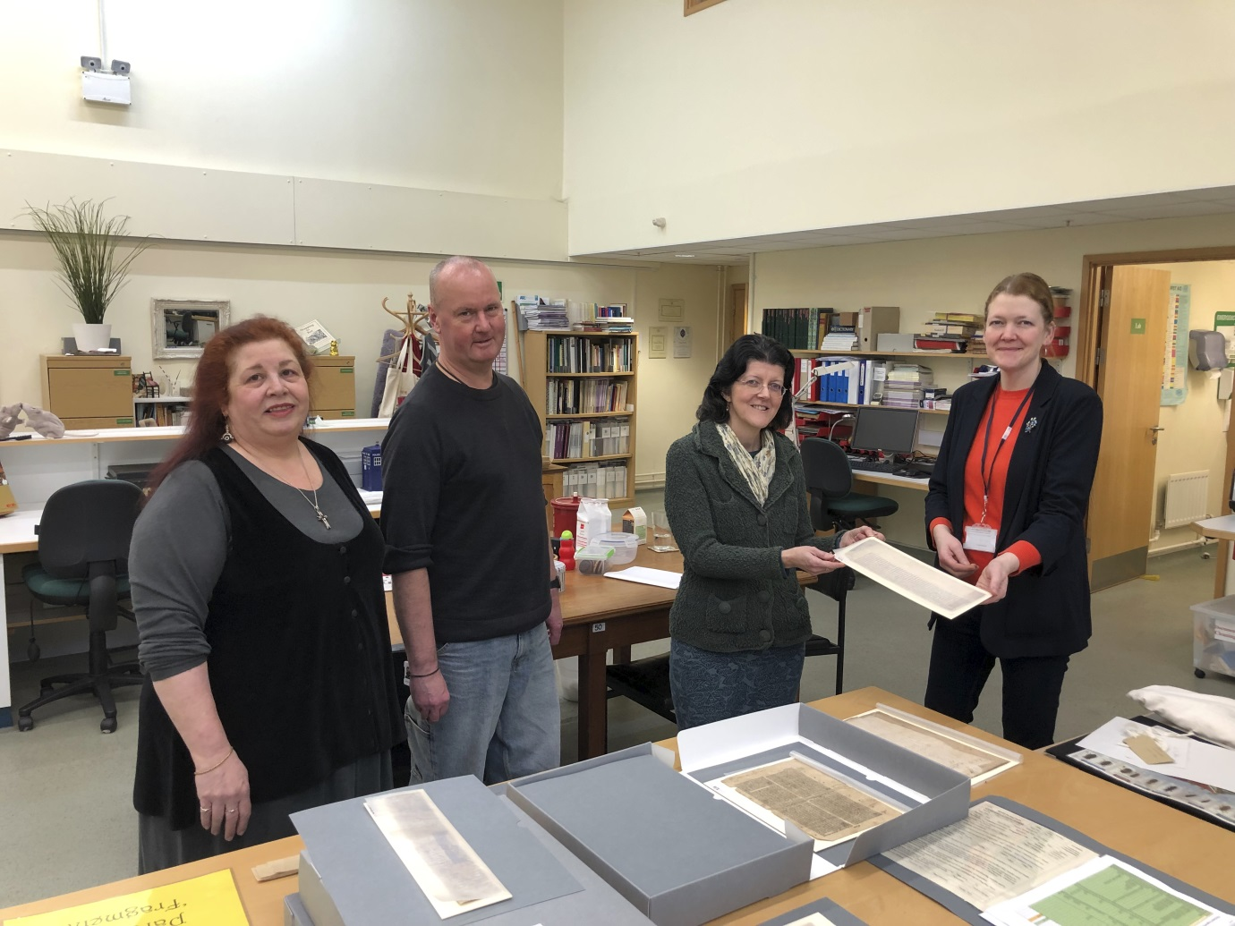

Devon & Exeter Institution

Digitising the Last Sketchbook of Francis Stevens

The Devon-born artist Francis Stevens (1781-1823), perhaps best known for his grand-scale painting of Lustleigh Cleve (1820), suggested he was still working towards a wider volume “illustrative of Exeter and his vicinity,” at the end of his life. A current project to digitise and transcribe the last known working sketchbook of this committed landscape painter, kept between June 1819 and July 1823, sheds light on Stevens’ artistic practices and intentions during his final years.

As well as being a celebrated watercolourist, (he was elected to full membership of the Watercolour Society in 1809), Stevens was a draughtsman and teacher, who seemed determined to record his developing impressions of an interesting scene. It is notable that in this small pocket sketchbook Stevens recorded his travels, ideas and observations in written as well as a sketched form. He discusses, for example, traversing the landscape around Berry Pomeroy with the celebrated artist J.M.W. Turner (1775-1851), as well as his interest in capturing certain “Effects.” Particularly, whilst observing the sea at Lynmouth, he declares “the Subject is Sublime,” a philosophical term redefined by Immanuel Kant in 1764, to describe the feeling of overwhelm in the face of nature’s untamed magnitude. At Barnstaple, Stevens declares even the lime kilns are “Picturesque.” Such observations place Stevens in line with wider contemporary movements in landscape painting, and the early nineteenth-century interest in moving away from recording a generalised view of nature. Whilst artists of the previous generation had largely sought to work in the tradition of the weatherless landscapes of Claude Lorrain (c.1600-1682), instead, Stevens focuses on the specifics, and on occasion labels his sketches with prospective colours- “light grey,” “dark grey,” or blue.”

The annotations dispersed at choice points in the sketchbook not only indicate at Stevens’ intention to “work up” the sketches into larger-scale landscapes, but also suggests that he may have intended these small drawn observations as preparatory pieces for his intended work on views “illustrative of Exeter and his vicinity”- a compilation which was still yet to come to fruition at the time of his death, though some of his drawings would inspire Frederick Christian Lewis’ (1756-1856) etchings for The Scenery of the River Exe (1827).

Stevens was an artist who was clearly keen on documenting the weathers and wildlife around his native Devon. A dedicated walker as well as a draughtsman, his sketchbook provides fascinating glimpses of local areas such as Colyton, Clovelly, Totnes, Teignmouth, Manaton, Lynmouth, Plymouth, Cranbrook, and Exeter. He is interested in houses, trees, boats, bridges, plants, skies, the “imployment [sic] of the people” as much as the “Effects” of the weather. Devon is captured in all its aspects, from the rugged tors of Dartmoor to the fishing industry of Teignmouth. At the same time, his observations and working practice is more widely revealing of the development of contemporary artistic movements and innovations, not least significantly the ability for artists to become more itinerant due to the growing accessibility of more portable drawing materials. Fitted with a brass clasp, Steven’s leatherbound pocket sketchbook measures only 180 x 120mm. In such circumstances, his notes on colour anticipate the availability of portable watercolour boxes, which would become widely commercially available under the title of a “shilling colour box” in 1830.

Nonetheless, Stevens’ himself expresses an awareness and an anxiety about how his work might be preserved in the future. He was sure, for example, to donate a volume of his Views of Cottages and Farm-houses in England and Wales (1815) to the Devon & Exeter Institution in 1819, and it is therefore fitting that after his death, his last working sketchbook came to join it. At the sale of Stevens’ estate, the fascinating volume was purchased by Sir Thomas Dyke Acland, who later donated it to the Institution. As Stevens recorded all of his impressions in pencil, a medium subject to fading over time, it is incredibly important to capture his remarkable legacy in digital form. Some of his notes, indeed, recorded in a small cursive pencilled hand, are still rather difficult to make out. If you would like to continue to puzzle out some of the words that continue to evade decipherment, you can view over sixty digitised pages of Stevens’ sketchbook, and the working transcriptions, on our collections explorer, “Our Region Revealed.”

Beth Howell, Digitisation Coordinator, Devon and Exeter Institution

Note: Website gives opening times as Tuesday to Saturday: Tuesday to Friday, 10-5; Sat, 10-4.

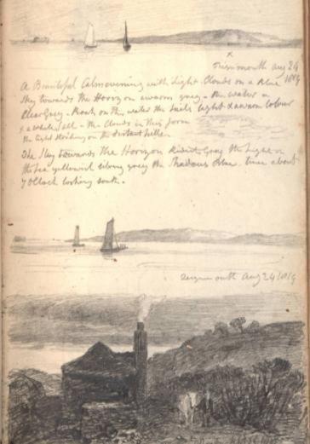

Brixham Heritage Museum

No reply, but website says the Museum is closed until Tuesday 22 February 2022.

Amanda Bouchier, Administrator

Torquay Museum

NIL RETURN from Barry Chandler. Website gives opening times from 1 February 2022: Open Tuesday, Wednesday, Thursday, Saturday, 10-4. Admission charges apply.

Barry Chandler, Torquay Museum

Tiverton Museum of Mid Devon Life

NIL RETURN from Pippa Griffith, but website says Museum open from 5 January 2022, Wednesday to Saturday, 11-4 and from 1 March 2022, Tuesday to Saturday, 10-4. Admission charges apply.

Pippa Griffith, Director and Mid Devon Museum Development Officer

Totnes Archives

NIL RETURN from Sue King. Website says the Archives are closed for Winter but open for online enquiries.

Sue King

Devon Rural Archive

DEVON RURAL ARCHIVE

EVENING LECTURE PROGRAMME 2022
.

Thursday, 3rd February 2022, at 7pm.
Devon’s Last Slave-Owners: emancipation & compensation in 1834.
Dr. Todd Gray, Historian.

Thursday, 3rd March 2022, at 7pm.
Some Local Myths and Legends.
Dr. Kevin Dixon, Historian & Author.

Thursday, 7th April 2022, at 7pm.
From ‘Lady Woodcarvers’ to Professionals:
the remarkable Pinwill sisters.
Dr. Helen Wilson, Local Historian.

Thursday, 5th May 2022, at 7pm.
A Thousand Year History of Thorn House and Garden, Wembury.
John and Eva Gibson, Thorn House, Wembury.

Thursday, 9th June 2022, at 7pm.
Footprints in the Sand:
the story of the Carews of Devon, 1086 – 1945.
Sir Rivers Carew, Author & Family Historian.

Thursday, 7th July 2022, at 7pm.
Marine Heritage on the Torridge Estuary.
Dr. Michael Teare, Way of the Wharves, Bideford.

Thursday, 4th August 2022, at 7pm.
The Hole Family of Parke, Bovey Tracey.
Dr. Frances Billinge, Hon. Assoc. Research Fellow University of Exeter.

Thursday, 1st September 2022, at 7pm.
The Icelandic Adventures of Pike Ward of Teignmouth.
Katherine Findlay, Heritage Consultant and Chair of Devon History Society.
Organised in association with Devon History Society & Friends of Devon’s Archives.

Thursday, 6th October 2022, at 7pm.
Spirit of Adventure: the Plymouth Blitz & the post-war rebuilding.
Dr. Clare Maudling, Researcher, Historian & former Library Professional.

Thursday, 3rd November 2022, at 7pm.
Rougemont Castle, Exeter:
an overview of archaeological work, 1985-2016.
Dr. Stuart Blaylock, Consultant Archaeologist and Architectural Historian.

Thursday, 1st December 2022, at 7pm.
Adventures in Romanesque Sculpture:
exploring the twelfth-century stonecarving of Devon and Cornwall.
Dr. Alex Woodcock, Stonemason, Author & Artist.

Tickets: £5 each
or £44 for a Season Ticket to attend all 11 lectures in 2022.

All lectures are held at the DRA, in the grounds of Shilstone House near Modbury. Complimentary refreshments are available from 6:30pm, when the Archive opens.

To purchase tickets, or for directions, please visit www.devonruralarchive.com

Devon Rural Archive, Shilstone, Modbury, PL21 0TW
T: 01548 830832 | E: office@dra.uk.net

Abi Gray

Contributions to future Newsletters

If you would like to contribute an article to the Newsletter, you would be most welcome. Please do get in touch with the Newsletter editor Sue Jackson via e-mail: sue.pete.jackson@gmail.com

Likewise, if you have any comments to make, please contact me.

Sue Jackson
FoDA Newsletter Editor

