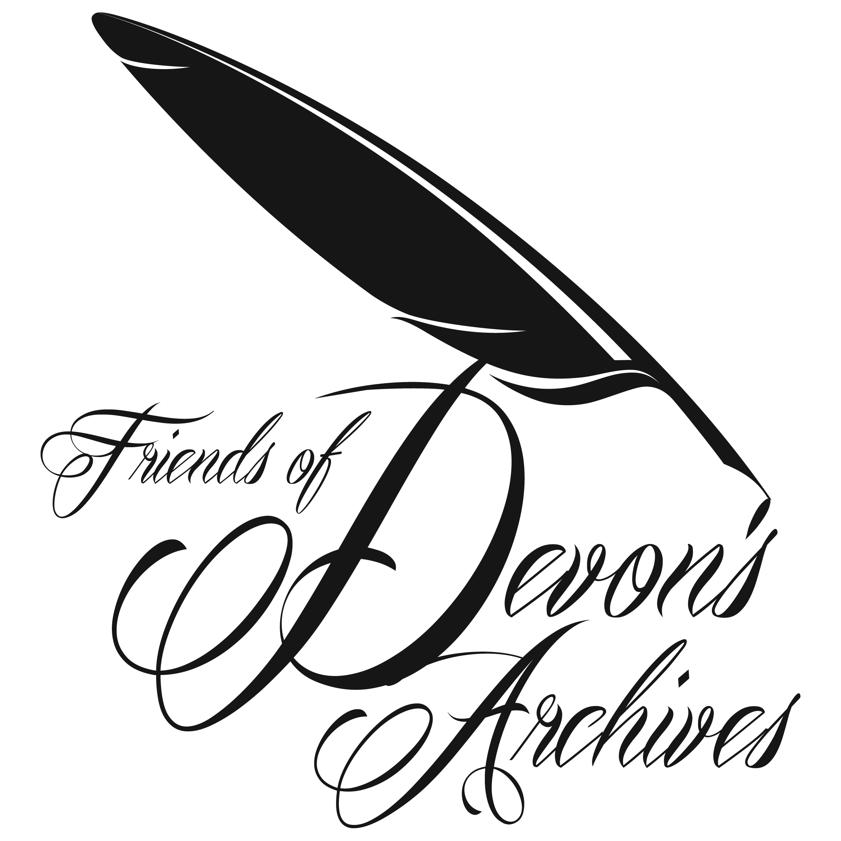

The Friends of Devon’s Archives
www.foda.org.uk
Registered Charity 1107394
c/o Devon Heritage Centre, Great Moor House,
Bittern Road, Sowton Exeter EX2 7NL.

Welcome to the Autumn 2020 Newsletter
It is with mixed feelings that I welcome you to our second newsletter under the cloud of Covid. I am increasingly aware that we are becoming a divided society – the haves - zoomers, teamers, whats appers and the have- nots – those uncomfortable with new technology, those who cannot access it and, shamefully, disadvantaged school children whose families cannot afford it. It is magnificent what the archive world is achieving in remote working and so important we disseminate our knowledge but it has been welcome news that that DRO, DRA and , most especially, the Plymouth Box are successfully up and running services safely – well done!

Katharine Chant, FoDA Chair

Dates for your Diary – Forthcoming Conferences

The 2020 FoDA Annual General Meeting will be held on Tuesday 24 November 2 p.m. at The Meeting Room, St Nicholas Priory, 21 The Mint, Exeter EX4 3BL
Please contact Brian. Carpenter@swheritage.org.uk if you wish to attend via Zoom and he will e mail you the link.
If attending at St Nicholas Priory, please book by e mailing friends_info@foda.org.uk

Joint DRA/DHS/FoDA Conference: Dr Ian Mortimer, The chief rents of Moretonhampstead, 1639-1840: how to use a problematic source. Cancelled for 2020, now arranged for Thursday 2 September 2021 at 7 p.m. at Devon Rural Archive.

Plymouth Update

The Box opened 29th September 2020.

The opening of Plymouth’s major new cultural and heritage centre took place on 29th September, four months after the original opening had to be delayed by Covid. By April, when the site had to close, the archive collection had been safely transferred from the PWDRO premises at Coxside and installed in the state of the art “box in the sky” at Tavistock Place. Since work resumed on site, the fitting out has been completed and the Archive team have installed their display of key archives in the Active Archive gallery.

Admission to The Box is free (other than to specific exhibitions, such as the current Mayflower 400 exhibition) but due to Covid is by pre-booked appointments, the arrangements for which are on the www.theboxplymouth.com website. There is a separate on-line procedure for reserving documents for inspection in the Cottonian Research Room, with appointments in afternoons only (Tuesday - Saturday) and limited to one per person, per month.

At the conclusion of this major project, mention should be made of the many years campaigning by our former Chairman Todd Gray to see the archives moved from the temporary premises which the National Archives condemned over 20 years ago and which are at long last safely re-housed. Credit should also be given to the civic leaders of both parties on Plymouth City Council who, with their officers, have worked since 2012 to evolve the plan to utilise the existing Museum and Art Gallery as the basis for the new complex and to give the “Plymouth archives” (as the National Archives now term the collection) a suitable and permanent home..

Richard Spear

Stop Press

Richard Spear will be standing down from the Committee at the AGM on 24th November, so there will be an opportunity for someone who uses the Plymouth archives to replace him on the Committee and maintain contact with The Box. Expressions of interest to him at speshr@aol.com and he will willingly provide further information. The role would include being on the database of The Box of supporting people and organisations, built up during the development phase but possibly to be used further in the future.

URGENT

FoDA NEEDS A WEBMASTER – PLEASE CONTACT FoDA (email on website) IF INTERESTED.

Update from the Membership Secretary

Membership has remained static during 2020.

Peter Towey, FSG, Membership Secretary, Friends of Devon’s Archives

SW Heritage Trust Report
Report for FoDA newsletter
September 2020

The last few months have been very different for the Devon Archives & Local Studies Services. We closed our services to the public on 18 March and were unable to offer onsite access to collections until 4 August.

We are really pleased that we have been able to open our public services again in a Covid-19 secure way. For the last two months we have been able to welcome up to 6 people per session at the Devon Heritage Centre and up to 4 people per session at the North Devon Record Office. The services are open for three days each week, with two sessions per day. We are receiving a lot of positive feedback from people using the service, who are pleased to be able to safely undertake their research.

There was plenty going on during the months when we weren’t able to be at our sites. During lockdown we answered 762 enquiries, embracing a wide range subjects, including the 1549 Prayer Book Rebellion, Henry VI’s visit to Exeter in 1452, and the 1943 air raid on Torquay. A huge amount of work was undertaken to expand our online catalogue, inputting data previously only available in paper copies in our searchrooms. This should greatly help researchers. Every accession of documents received by the former East Devon Record Office between 1946 and 1968 is now recorded on our database, creating a searchable inventory of these collections for the first time. Several hundred important medieval deeds from the Exeter City Archive collection are now also listed and available via the online catalogue. Staff at the North Devon Record Office concentrated on creating an electronic location index, which will help greatly in providing access to collections in the future.

We produced regular content for our social media platforms including #Archive30 during April, where we tweeted every day about an archive related subject. We also contributed to the national History Begins at Home campaign, which aimed to support well-being through online archival content. You can also read a number of new blogs on our website (https://swheritage.org.uk/news/) on subjects including the Exeter City Football Club Archive, accessing archives during lockdown, VE Day in Devon, the Devon Quarter Sessions Cataloguing Project, and stories about four prominent Devonians which was written to celebrate Devon Day on 4 June. We also contributed an extensive article about Devon archives to the Who Do You Think You Are? magazine.

Partnership work has continued, both during lockdown and since reopening. We were able to give a presentation at the Crediton Local History Day online event in July. Work with Exeter Cathedral has continued, with conservation being undertaken on some of the remarkable archives held in their collection. You can read more about this partnership on our website at https://swheritage.org.uk/news/our-partnership-with-exeter-cathedral/

We have also continued to receive new acquisitions. With generous support from the Friends of Devon’s Archives and others we were able to acquire a Tudor court roll relating to the manor of Bampton. This purchase has generated considerable interest following publicity about the acquisition on our website.

We have been successful with several funding applications which were written during lockdown. This funding is enabling us to upgrade our digital preservation system to a newer more streamlined version and test opportunities of working with other smaller archive services on digital preservation. We will also be hosting a digital trainee for 15 months during 2021-22, as part of The National Archives’ ‘Bridging the Digital Gap’ initiative. Devon is part of a collaborative partnership with Dorset, Gloucestershire and Warwickshire and will be sharing opportunities for training and information exchange about meeting the needs relating to digital archives.

Janet Tall, Head of Archives & Learning
Irene Andrews, Devon Archives & Local Studies Manager

Bampton Court Roll

A Window on Tudor Bampton

One of the most important roles played by the Friends of Devon’s Archives since its formation in 1998 has been the provision of funds to help the county’s archive repositories purchase documents.

Over recent years, FoDA has assisted with the acquisition of such valuable items as the eighteenth century ledgers from the Royal Devon and Exeter Hospital which were transferred to the Devon Heritage Centre in 2019, and a range of other items, often deeds and other property-related documents, which have found permanent homes in the archives in Exeter and Barnstaple.

This year an opportunity arose for the Devon Archives and Local Studies Service to purchase a Court Roll, dating from 1547 and 1548, for the manor of Bampton in Mid Devon, and the FoDA committee were happy to commit a substantial sum which, together with other contributions, enabled the document to be bought at auction.

Court rolls are immensely valuable documents as they contain large amounts of information about the day-to-day lives of ‘ordinary people’ from periods in which parish records may not exist, and written correspondence was the preserve of the literate elite. The archive service holds many thousands of manorial records from throughout the county, many of which are rolls such as this, which record the proceedings of manor courts which, before the development of local government and judicial administration, were the main ways in which law and order and individual behaviour were regulated.

Examples provided by the Bampton roll include several people brought before the court by the manor’s official ale tasters for selling alcohol illegally, or in incorrect measures. Twenty-seven people were fined a total of 7s 6d for this particular offence in March 1548 alone. At the same court twenty people received fines of 4d each for allowing their pigs to wander in the streets. There were also a number of fines for trespass, a common offence at a time when it was all too tempting to take a short cut across a neighbour’s property or graze livestock on their land.

There were also more serious offences, including an assault with a ‘cutting knyff’; and there were other violent incidents involving a ‘thrasshell’ (presumably an agricultural implement relating to threshing) and a billhook.

One family in the manor appears to have been particularly dubious. William Bowbeare the younger was fined 4d for allowing people to play at dice and cards in his house on feast days, while Alice, the wife of William Bowbeare the elder, and probably the mother or aunt of the younger William, was charged with being a communis scandalozatrix (a common scold or slanderer) to the nuisance of her neighbours. It would be wonderful to know who her barbed comments were directed at, and what she was saying, but this was not recorded.

The archive service and the South West Heritage Trust are extremely grateful for the continued support of the Friends of Devon’s Archives, especially during a period when the service has not been able to operate in the usual way for reasons we are all aware of.

Brian Carpenter
Devon Archives and Local Studies Service

Norden Survey

FoDA’s NORDEN PROJECT
17th Century Communities in Devon: People and their Landscape in the Norden Survey of 1613.
Frances Billinge and David Stone
July 2020

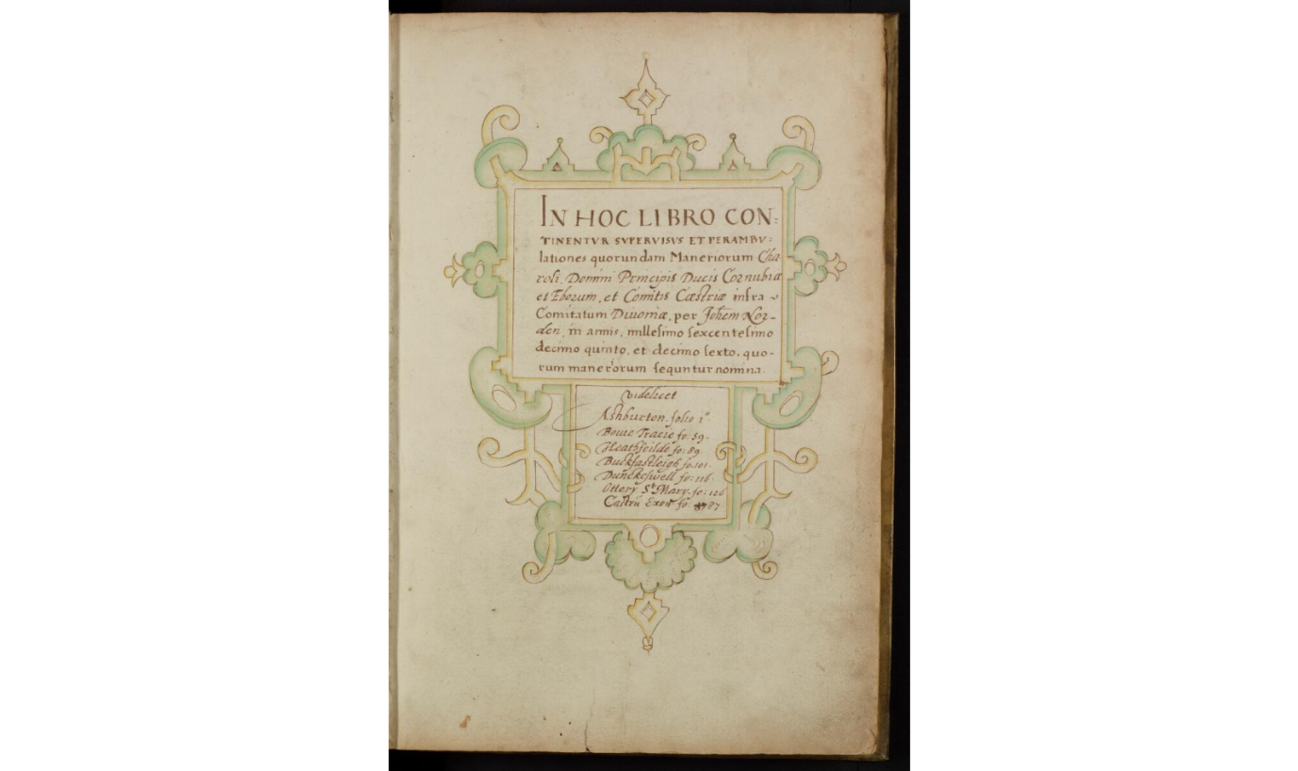

Front page of Norden Survey of Various Manors of Devon by courtesy of London Metropolitan Archives

BACKGROUND
Through the research of a member of FoDA, John Norden’s 1613 survey of various manors in the County of Devon came to light. In March 2019, FoDA held a successful seminar jointly with the Devon Archaeological Society to raise awareness of the survey and to seek volunteers to help work on it. There was much enthusiasm among members of FoDA and other societies and, at the end of 2019, FoDA put in a successful bid to the National Lottery Heritage Fund so that the survey could be transcribed, translated and published, both in a printed edition and online.

John Norden was a surveyor and cartographer who surveyed Crown lands for James I in the early 1600s. Norden’s work is fully described by Frederick Lewis in the Oxford Dictionary of National Biography.¹ Further information is also given in Heather Lawrence’s article of 1985.²

Needing to raise money, the Crown had started to sell some of its estate from the middle of the 1500s.³ This policy was continued by James I who, in 1612, granted John Norden surveyorship of the King’s lands in several counties including Devon in preparation for the sale of these lands.⁴

Famously, Norden’s surveys were sometimes accompanied by a map, but in many instances these documents were (as they had been for centuries) simply a written description of manorial land and resources. In Northamptonshire, for example, his written description of the parish included mileage between places and lists of the landholders.⁵ He undertook his survey of the Crown lands of Devon in 1613-4 and this was written-up in manuscript form, without maps, by 1615.⁶

Norden’s survey of the Devon Crown lands covers Ashburton, Bovey Tracey, Bradninch, Buckfastleigh, Dunkeswell, Exeter Castle, Heathfield, and Ottery St Mary. The surveys, which together form four hundred pages of a single manuscript, are written in a mixture of Latin and English and are available on-line at the London Metropolitan Archive. Frank Kitchen explained the methods which Norden used in his surveys, which varied depending on what was required.⁷ Norden attended courts, examined records, and physically inspected the ground, compiling a register of holdings, tenants, values, and obligations, together with many incidental but illuminating details. He made marginal notes to raise queries, using manicules for particularly questionable points of legality. Consequently, the surveys contain a wealth of social and economic information about the areas covered.

THE PROJECT
Dr David Stone is leading the project and Ros Palmer has kindly agreed to be the administrator for it. Although the lockdown coincided with the start of the funded phase of the project and forced the cancellation of the first formal meeting of this phase (which was due to be held at the Devon Rural Archive in late March), the last few months has still seen considerable progress being made. We have had several new volunteers join us, bringing the total number of transcribers/translators who are working on the eight manorial surveys to 19. As well as being in email contact with volunteers, David has held Zoom meetings with the majority of those involved in order to introduce people to one another, to help with any issues that have arisen, and to discuss the possibilities for local, contextual research. Good progress has already been made on transcribing and translating some of the surveys: indeed, transcriptions for some of the manors are already very well advanced. In Zoom meetings with volunteers, David has been keen to stress the need for consistency across the different parishes, which is one of reasons why, at this stage, it is important to work towards a transcription as well as a translation of the surveys.

The project will also entail the carrying out of research into the local history of the different manors, allowing the survey to be put into context and the history of personal names, field names, and manor boundaries to be explored. This will hopefully enable connections to be made with later documents but also encourage volunteers to peer back into the sixteenth century and perhaps even into the medieval period in the search for information about local people and their landscape. As Bradninch, for example, was a manor held by the duchy of Cornwall, the existence of documentary references casting light on the material contained in the Norden survey is highly likely. Such contextual work will not only inform the final printed and on-line edition of the work, as local talks, walks, and the ‘beating of bounds’ will, in due course, also be arranged.
To bring Norden’s work in a full circle, it may also prove possible to map some areas and aspects covered by the survey. This may, for example, include consideration of park and barton land, as well as the fieldscape and land use more generally. Reconstruction of the landscape over time would be greatly aided by nineteenth-century tithe maps and Ordnance Survey maps, together with the use of Geographic Information Systems. Such a method, of course, is already used by Know Your Place.

The project will be a main item at the 2020 FoDA AGM on 24 November, to be held at Devon Rural Archive. All FoDA members are welcome to be part of this project: if you are interested, please contact: davidstonemedievalist@gmail.com or make your interest known through the FoDA web-site. There will be a progress report in the next Newsletter. UPDATE THIS INFORMATION

REFERENCES
- Frederick Lewis 2008. John Norden. Oxford Dictionary of National Biography (Oxford)
- Heather Lawrence, 1985. John Norden and his Colleagues, Surveyors of Crown Lands in The Cartographic Journal 22, vol. I, pp.54-5.
- All of the following describe the selling of Crown land - John Kew, 1967. The land Market in Devon 1536-1558. Unpublished Ph. D. thesis University of Exeter.; John E. Kew, 1967. Mortgages in Mid-Tudor Devonshire in Trans. Devon. Assoc., Advmt Sci.vol.99, pp.165-179; John Kew, 1970. The Disposal of Crown Lands and the Devon Land Market, 1536-58 in Agricultural History Review xviii, vol.18, pt 1, pp.93-105.
- Calendar of State Papers Domestic Series James I, 1611-1618, p. 158. 26 November 1612, ed. Mary Anne Everrett Green, HMSO, 1967.
- John Norden,1610 published 1720. Speculi Britanniae Pars Altera: or A Delineation of Northamptonshire, (London).
- London Metropolitan Archives. John Norden ; 1615-16 Survey of Devon manors CLA / 044/05/04, available on line www.cityoflondon.gov.uk At the time the manors were mortgaged to the Corporation of London which is why the document is in the City of London Archives.
- Frank Kitchen,1997. John Norden c. 1547-1625, Estate Surveyor, Topographer, County Mapmaker and Devotional Writer in Imago Mundi 49, pp. 43-61. Page 50 describes the background of Norden’s work and page 54 describes Norden’s methods.

Devon Bibliography

Westcountry Studies. Issue 17. September 2020.

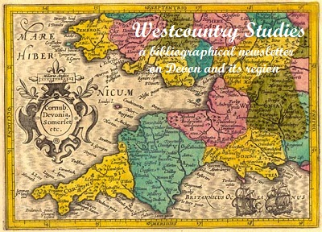 | Westcountry Studies  a bibliographical newsletter  on Devon and its region  Issue 17  September 2020

Covid-19 - again
There is little to report on the Devon bibliography front and few new publications have been added to the list of 2020 publications. I remain concerned about the documentation of Covid-19 in Devon and actually approached Granicus to see whether there is any way of obtaining URLs for the bulletins that they distribute on behalf of many local authorities and other bodies. They replied that it was a matter for the individual local authorities and, of those I subscribe to, only Devon offer a web alternative. I am way behind in updating the list of bulletin URLs I have received from Devon County Council which I included in my last newsletter and it is not really up to me to chase the other local authorities in Devon. Hopefully they will be archived by the UK web archive as the Wayback Machine seems very haphazard in picking them up. My tentative bus trips round Devon have found few tourist offices open and the few 2020 tourist guides and leaflets I have picked up were clearly produced and distributed before lockdown and are blissfully unaware of the existence of Covid-19, with lists of events that never took place. Not that publishers have been entirely idle. The Newton St Cyres History Group for example have produced two publications: Stella Cork's Newton St Cyres in the 1940s and 1950s and Newton St Cyres and the Civil War 1642-46 by Jean Wilkins. There may be other local publishers and local organisations active, but distribution is a major problems with many outlets closed and post offices often remote. In Crediton Andrew Davey at the wonderful Crediton Community Bookshop drew my attention to a Mint Press publication which Waterstones in Exeter had not yet picked up: T. P. Wiseman's Exeter and the ancient world.

Libraries and archives are now opening again and are also providing on-line services but in Westcountry Studies Library Covid-19 has clearly taken its toll. While the catalogue lists just over 100 Devon books and pamphlets for 2019 (the 443 items claimed include over 300 for "19--"), there is only one item for 2020 as of 18 September. Exeter Central Library participated in Heritage Open Days this year in a number of ways, including a virtual stack tour by Stock Manger Jo Lawrence featuring Exeter Library's oldest book, dating from 1480.

Sabine Baring-Gould
I have recently received news of the death of Roger Bristow, the compiler of the bibliography of Sabine Baring-Gould's extensive output of more than 1,000 publications. A sad loss - his work was most helpful in connection with my work on the Baring-Gould Library in Lewtrenchard. Earlier in September I visited Lewtrenchard Manor to deliver items from the Shacklock Collection that had been sent to my home during lockdown and was pleased to find the hotel once more open and busy.

Two rival Devon publications of 1829.
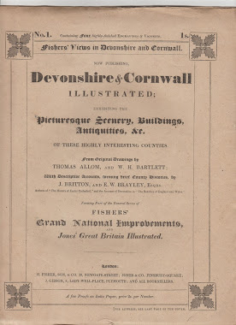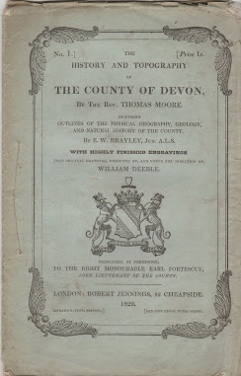

On 1 September 1829 the first part of two publications appeared simultaneously, each containing two topographical prints of Devon, and parts of each continued to appear monthly until July 1832 in the case of Fisher, Son and Co's Devonshire and Cornwall illustrated and until July 1833 in the case of Jennings and Chaplin's The history of Devonshire from the earliest period to the present, by Thomas Moore. By that time each had published 94 finely engraved plates of Devon, plus Cornwall items in the case of Fisher's publication. These were a far bigger tally than any previous illustrated publication for Devon and were only exceeded later by the Devon plates in the series of small vignettes by Henry Besley whose 117 vignettes appeared between 1852 and 1875, and the national series of Barnstaple born William Rock, published between 1848 and 1876. In Germany this rivalry has intrigued Kit Batten, author with Francis Bennett of cartobibliographies of Devon and I have been helping him to unravel the complex publishing history by examining the incomplete set of original parts of Moore's volume held in the Westcountry Studies Library. Kit is publishing the results of his researches online in Two illustrated books on Devon, 1829 and has provided me with an almost complete set of high resolution images from the two publications which will be included in the revised Etched on Devon's memory website. The images can now be allocated to individual parts and more precisely dated, which will enhance the bibliographical information available for each print.

Budleigh Salterton Literary Festival
The festival is running as I draft this newsletter, from 16-20 September, and all events are freely available on the web until 30 September. Those I have watched are excellent and, of course they include our local literary luminary Hilary Mantel, two of whose publications are included in the virtual bookshop. The organisers are to be applauded at the way they have circumvented lockdown and deserve the donations that they have requested for mounting the events on-line without the benefit of ticket sales.

Pike Ward and Iceland
In July I noticed a photograph album of views of Iceland which Pike Ward had put together as a gift in 1904. It was offered for sale at a not inconsiderable sum by an American bookseller. The bookseller had generously placed a number of the images on the sales pitch and it revealed that most of them are already represented in the albums which formed part of the Westcountry Studies Library, so staff at the Devon Heritage Centre agreed that it would not be necessary to acquire them. However Katherine Findlay, author of Pike Ward's Icelandic adventure made contact with the National Library in Reykjavik and it is good to know that the album has now found an appropriate home there. Apparently the library had few original photographs by this notable Devonian Icelander. I have a soft spot for someone who could call his home on the bleak slopes of Isafjordur Rose Cottage and his house in Teignmouth Valhalla.

A literary forgery revealed in Exeter
Digging for illustrations to illustrate the section on early Italian printing in my international survey of printing history, I had confirmed what I had come to suspect, that the second oldest book in Exeter Library's cage is not the real thing.

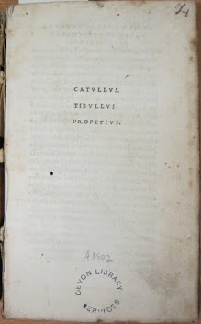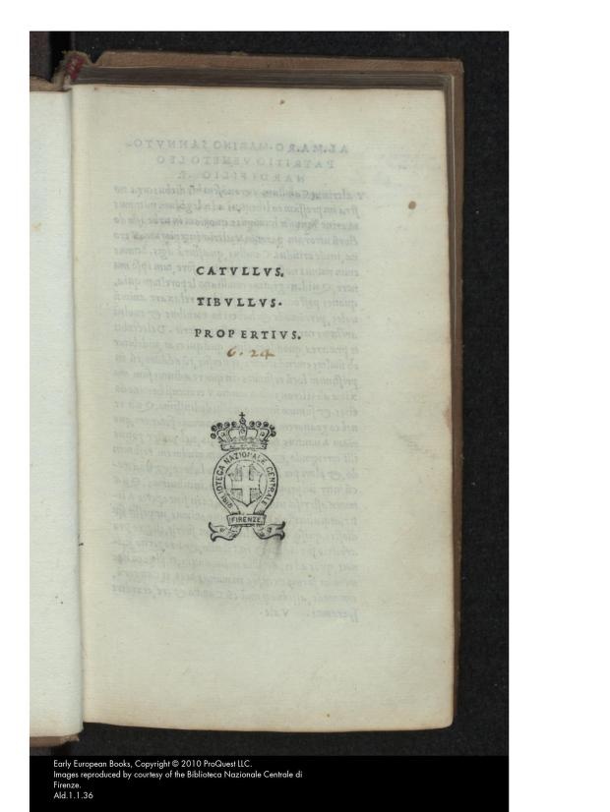

The more eagle-eyed among you will notice the slight difference in the two title pages. Exeter's on the left has the spelling "Propetius" while the one on the right from the Internet Archive has the correct "Propertius". I had been surprised that such a lapse should have passed the attention of the scholarly Venetian printer Aldus Manutius and my hunch was proved to be correct. Exeter's copy was produced not in Venice but in Lyon, from the workshop of Baldassare Gabiano. This printer had started his career with his uncle Giovanni Bartolomeo de Gabiano, a bookseller in Venice, but found it more profitable to move to Lyon in the 1490s and issue pirated editions of Aldus Manutius - cheaper but not so carefully produced as the originals. So, it remains Exeter Library's second oldest book, but sheds an interesting light on early book trade practices - and the library does still have genuine Aldine editions in its cage.

A clarion call for libraries
Radio 4's book of the week recently was Richard Ovenden's Burning the books: a history of knowledge under attack (John Murray, 2020). Written by Bodley's Librarian, who has lived through many of the assaults on books and libraries and who works in an institution which has worked to accumulate and spread knowledge and information for more than four centuries, it is an important statement on the key role of libraries, even in the digital age when funders have breathed a sigh of relief that now the book is finally dead and we no longer need to fund these expensive warehouses with their associated specialist staff. The author is clear that libraries should reclaim the data that is in the hands of a few tech companies. He asks in the section entitled "The digital deluge": Is knowledge less vulnerable to attack when it is controlled by private organisations? Should libraries and archives still have a role to play in stewarding digital memory from one generation to the next as they have done since the ancient civilisations of Mesopotamia?" His answer is in the final section: "Why we will always need libraries and archives". He defines five key functions of libraries:
- They support the education of society as a whole and of specific communities within it.
- They provide a diversity of knowledge and ideas.
- They support the well-being of citizens and the principles of the open society through the preservation of key rights and through encouraging integrity in decision making.
- They provide a fixed reference point, allowing truth and falsehood to be judged through transparency, verification, citation and reproducibility.
- They help root societies in their cultural and historical identities through preserving the written record of those societies and cultures.
In the book he follows through a number of case studies of knowledge under attack from nations that have seen the power and danger of knowledge, and have seen the destruction of libraries as the annihilation of the community memory and hence the identity of a society - a form of ethnic cleansing. I remember visiting the shell of the National Library in Sarajevo in 2007.

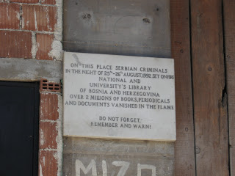

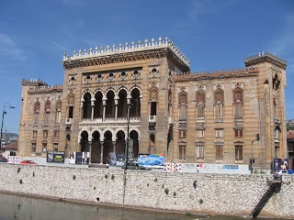

Propped against the closed main entrance were a number of withered bouquets - a pathetic sign that some people at least realised what Bosnia had lost.

The author brings the discussion closer to home in almost the last page of the book when he states: "Libraries, record offices and local history centres have wonderfully rich collections where often very rare and obscure materials are acquired (often by donation) and gifted to the local 'memory institution'. This work often goes uncelebrated and is often very poorly funded. A renewal of emphasis on local history might help local communities develop a greater sense of their own place, helping to bind them together, encouraging more understanding of who we are and where we come from.

UNESCO City of Literature
Hopefully this awareness of the key role of local studies collections will be heightened in Devon by Exeter's recent award. Work is well under way in putting together a programme for the four year Exeter initiative. I have been in contact with the organisers and have offered the contents of the Exeter Working papers in book history the Devon bibliography and Etched on Devon's memory websites. Rescuing and updating the From script to print to hypertext exhibition of 1999 from the Wayback Machine as a structure, I am also transcribing some of my extensive manuscript lecture notes as the World book heritage website to serve as a resource base for projects. Something to keep me busy during the coming winter lockdown.

Ian Maxted

Other News Items

From Devon Family History Society

At the moment, our research centre, Tree House, remains closed. However, some of the volunteers are busy answering queries and undertaking research as the ‘virtual’ Tree House team. We will look forward to welcoming visitors again once it is safe to do so – details of the ‘virtual’ service and news will be posted on our website.

Use our Keyword Search to see what’s at Tree House: http://www.devonfhs.org.uk/tree-house/

Email: treehouse@devonfhs.org.uk

Devon FHS’s programme of virtual meetings is available here: http://devonfhs.org.uk/groups/

These meetings are free to both members and non-members. They are delivered using the Zoom platform. To receive details of the ongoing meetings, sign up to our Mail Chimp mailing list at http://eepurl.com/cF1G8n. Once you have signed up, you will be sent an email to verify your request to join the list and a few days before each meeting, you will be sent details of how to join.

Maureen Selley, Secretary – Devon Family History Society and Mayflower Maker

Accessions & Reports from Archives around Devon

Devon Heritage Centre

2020 ACCESSIONS
Accession no. | Collect’nref. | Title of  collection | Description of contents | Date Range | Date of deposit | Extent
D2020/1 | ZAWK | Hook of Honiton | Copy will, Ann Hook of Honiton | 1834 | 02-01-2020 | 1 item
D2020/6 | ZAWO | Bishop Blackall School | Report & programme, Exeter Episcopal Modern School, 1932-33, school magazine, Bishop Blackall School, 1934 | 1932-1934 | 09-01-2020 | 3 items
D2020/7 | ZAWP | Ramblers Association: Devon Area | Records of the association | 1994-2019 | 10-01-2020 | 2 boxes
D2020/10 | ZAWR | Dutton Collection | Research material and photographs, Bury Barton, Lapford. | c. 1965 - 2019 | 13-01-2020 | 3 files
D2020/11 | ECC | Exeter City Council | Additional deposit, records from the Lord Mayor of Exeter's office. | 1983-2015 | 17-12-2019 | 2 files
D2020/14 D2020/37 | ZAWS | Ashmole and Limmer Families | Photographs, sketch book, genealogical papers | 19th-20th century | 15-01-2020 10-02-2020 | 3 vols,  3 files
D2020/15 | 4386A | Borden Gate Parish Council | Additional records including minutes, planning application papers, correspondence, papers | c. 2009-c. 2017 | 16-01-2020 | 2 boxes
D2020/16 | 3420A | Stokein-teignhead Parish | Additional records including graveyard plan, 1973. | c. 1933 - c.1983 | 16-01-2020 | 1 bundle
D2020/17 | ZAWT | H. E. Williams Motor Works | Black and white photograph, 38-41 Catherine Street, Exeter, with employees | c. 1920 | 20-01-2020 | 1 item
D2020/19 | ZAWU | Martin Collection | Papers, volumes relating to the Martyn/Martin Family |  | 20-01-2020 | 1.5 boxes
D2020/20 | 8695Z | David Thomas Collection | Additional deposit - research papers on James Green, surveyor | 20th century | 22-01-2020 | 1 file
D2020/21 | ZAWV | Chardstock Historical Record Group Collection | Wills, probates and admons, 1738-1885, with typed transcripts 21st century. | 1738-21st century | 22-01-2020 | 0.5 box
D2020/22 | ZAWW | Blackmore Family | Records relating to the Blackmore family and their relations. |  | 24-01-2020 | 1 bundle
D2020/24 | ZAWZ | Bleckly Family | School and college photographs, nursing certificates and testimonial | 20th century | 29-01-2020 | 5 photo-graphs, 1 file
D2020/26 | ZAWY | Castle Drogo Research | "The Drogo Chronicle" articles on the building and estate, researched and written by staff and volunteers | 2016-2019 | 30-01-2020 | 4 files
D2020/27 | DRP | Devon Remembers First World War Collection | List of First World War material held at Devonport Naval Heritage Centre | 2018 | 31-10-2018 | 1 USB Stick
D2020/28 | DRP | Devon Remembers First World War Collection | 38 World War One at Home recordings by BBC Radio Devon with accompanying documentation. | 2014-2015 | 10-02-2015 | 1 file, + digital audio records
D2020/29 | DRP | Devon Remembers First World War Collection | Report and images, KU Leuven Conference, Brussels, 13 Sept 2018: "Where do we go from here? One Day Symposium on Belgian Refugees." | 2018 | 12-11-2018 | 1 file
D2020/30 | DRP | Devon Remembers First World War Collection | Ernest Samuel Vigers Collection | 1908-1930 | 20-11-2018 | 6 items
D2020/36 | ZAXD | Nodder Collection | Letters, Miss Eileen Nodder to Miss Audrey Tucker, Second World War, with newspaper extract on blitz death | 1940-1942 | 07-02-2020 | 1 file -
D2020/39 | 2696G | Devon Federation of Young Farmers' Clubs | South Dartmoor Young Farmers' Club records & photographs; Devon Young Farmers' Clubs Yearbooks, 1971-1992, annual report, 2004-2005, National Federation annual reports, 1956, 1981, 1982. | 20th-21st century | 18-02-2020 | c. 2 boxes
D2020/40 | ZAJX | Exeter Camera Club | Additional papers and articles, club administration | 20-21st century | 18-02-2020 | 1 box
D2020/41 | 4304B | R.W. & F.C. Sharp Ltd, timber importers and builders’ merchants, Exeter and Exmouth | Fifth additional deposit, including family photographs, correspondence, & other documents. |  | 18-02-2020 | 2 boxes
D2020/42 | ZAXF | Foot and Mouth Disease in Broadwood-kelly, Devon | Digital recordings of interviews with farmers relating their experiences of Devon foot and mouth disease outbreak. | 2001 | 19-02-2020 | 1 CD-Rom disc
D2020/43 | ZAXG | Devon Images | Colour slide, building the M5 motorway, Sowton, aerial views of Winslade Park, Clyst St. Mary, County Show and other images. | 20th century | 18-02-2020 | 1 small box
D2020/44 | 7084G | Whipton and Exeter Choral Society | Additional records, Exeter Choral Society, formerly known as Whipton Choral Society | 1955-2018 | 25-02-2020 | 1 file, 1 USB stick, 1 disc
D2020/46 | ZAXH | Hodge of Sidmouth | Apothecary's book, B. T. Hodge of Sidmouth, & 12 sheets of medical notes. | 1842 | 26-02-2020 | 1 vol;  1 file
D2020/47 | 7505G | South-Western Naturalists' Union | Additional records of the South-Western Naturalists' Union, later the South West Natural History Union | 1922 - c. 2012 | 27-02-2020 | 2 boxes
D2020/48 | 8134G | North Huish and Diptford Local History Society | Additional local history material relating to North Huish, Diptford and other parts of South Devon |  | 24-10-2019 | 1 box
D2020/49 | 2359D | Plymouth and Exeter Methodist District | Additional transfer, quarterly circuit preaching plans | 2015-2018 | 03-03-2020 | 5 folders
D2020/50 | DRP | Devon Remembers First World War Collection | Nurse Gooding VAD, Exeter War Hospital No. 3: Photographs & autograph album | 1904-1919 | 10-01-2019 | 1 album  6 files
D2020/51 | DRP | Devon Remembers First World War Collection | Chandler Photocards: photographs of injured men & nurses | 1914-1918 | 10-01-2019 | I file
D2020/52 | DRP | Devon Remembers First World War Collection | Mary Perkin, Red Cross VAD, Exeter War Hospital No 3:  Photocopied photographs, transcript autograph book, letters | 2018 | 25-01-2019 | 1 file
D2020/53 | DRP | Devon Remembers First World War Collection | Notes on Farming Memories during 1914-18 | 2017 | 30-01-2019 | 2 sheets
D2020/54 | DRP | Devon Remembers First World War Collection | Audio files: interview with Michael Clapp re his grandmother Alice Clapp’s work relieving Belgian refugees in Exeter 1914-18,  with transcript | 2018 | 30-01-2019 | 1 file,  2 CD-Rom discs
D2020/55 | 2812D | Methodist Records: Thorne Collection | Part of 17th additional deposit to the collection | 1794-2000 | 03-03-2020 | 6 volumes, 1 file
D2020/56 | ZAKR | Devon Deeds and Documents | Deeds & papers, Tamerton Folliot, Marytavy, Topsham, Buckland Monachorum, Kingskerswell, Exeter; Bideford; papers, Woodley family of Widecombe in the Moor, Ashburton and Ilsington 1807, private apprenticeship indentures. | c. 1726-1881 | 04-03-2020 | 0.75 box
D2020/57 | GRE | Greeves Collection | Assorted conveyances, sale particulars, papers, photographs, mine plans & sections; photograph album, Hannaford family of Widecombe in the Moor, late 19th century; papers & photographs , Derek G. Broughton of Chagford, mining historian (c.1933-1971); letters, photographs, re: evacuation of the South Hams, World War II; The Devon Tin Mining Industry, 1450-1750, Ph.D thesis, Tom Greeves, Oct. 1981. | 1798-late 20th century | 03-03-2020 | c. 4 boxes
D2020/58 | 6035Z | Lois Deacon Collection | Additional literary papers of Lois Deacon, novelist (c.1899-c.1985 | mid-20th century | 03-03-2020 | c. 1.5 boxes
D2020/59 | ZAXI | East Devon Documents | Deeds and papers, Luppitt, Thorncombe, Colyton; sale partics., Colyton | 1671-1953 | 06-03-2020 | 1 bundle (5 items)
D2020/60 | ZAXJ | Ottery St. Mary Deeds | Deeds and abstracts of title | 1809-1884 | 05-03-2020 | 1 bundle
D2020/62 | ZAXL | Rose Cottage, Cornworthy | Deeds and papers | (1863)-1998 | 06-03-2020 | 1 bundle
D2020/63 | ALF | Alford of Uplyme | Records of Alford family of Uplyme and their farming activities, including records of Harcombe Farm and Beech Farm, Uplyme, and Park Farm, Musbury. Includes animal movement books, rural payment records, late 20th century; scrapbook, Woodbury School near Axminster. | 20th -21st century | 19-02-2020 | c. 6 archive boxes
D2020/64 & D2020/88 | ZAPG | St. David's Players | Additional deposits including programmes, performances of Gilbert and Sullivan productions. | 1986-2019 | 09-03-2020 03-08-2020 | 20 bundles
D2020/68 | 1260F | Royal Devon and Exeter Hospital | 10th additional deposit, assorted records of Royal Devon and Exeter Hospital, rescued from destruction by staff including material relating to nurse training | 1898-1999 | 13-03-2020 | 1 bundle, 3 volumes
D2020/69 | ZAXO | Royal Devon and Exeter Hospital Nurses League | Records of the league, comprising newsletters and magazines. | 20th century | 13-03-2020 | 3 bundles
D2020/70 | 3250A | South Brent Parish | Additional ecclesiastical parish records transferred from family collection | 1866-1972 | 16-03-2020 | 1.5 boxes
D2020/71 | ZAXP | Chulmleigh History | File, history of Chulmleigh parish and church compiled by the late Reverend H. T. Cook | mid-20th century | 17-03-2020 | 1 file
D2020/72 | 7324C | Historic Environment Record, Devon County Council | Additional records relating to the work of the Historic Environment Record | 20th century | 17-03-2020 | c. 4 shelves
D2020/74 | 2056F | Whitestone | Additional records of Whitestone Church House Educational Foundation | 20th century | 17-03-2020 | 1 bundle
D2020/75 | 8324A | Devon County Council | Annual Survey of Holiday Development, 1949, 1956-1979; tourism trend reports, 20th century | 20th century | 17-03-2020 | 1 large volume, 2 files
D2020/77 | ZAXQ | Venn Collection | Photographs, Bathpool Food Flying Squad's work during and after the Lynmouth Flood Disaster, North Devon;  booklet, 1952. | mid-20th century | 07-04-2020 | 1 file, 1 booklet
D2020/78 | ZAXR | John Davies Rogers, R.N. | Documents, life and career of Commander John Davies Rogers R.N. | 20th century | 07-05-2020 | 1 file
D2020/80 | ZAXT | Slate Quarry Companies | Copies, records from TNA (Reference: BT) Van Slate Quarry Company, London, dissolved 1872, of property transferred to Devon Slate Quarries Company Limited; Dean Prior Slate Quarry, West Leigh Slate and Slab Company, Ashburton Slate Quarries Limited, all dissolved 1880s. | 20th century | 07-07-2020 | 1 file
D2020/81 | ZAXU | Manor of Chillaton, Milton Abbot | Manuscript copies, survey of properties in Manor of Chillaton, Milton Abbot, copied from original survey by W.T. Stentaford, Stoke Climsland; 3 maps by T. H. Lakeman, of tenements in Milton Abbot, Brentor and Sydenham Damerel. | 1831 | 07-07-2020 | 1 bundle maps/plans with associated reference sheets
D2020/82 | ZAXV | Second World War Memories | "Wartime Memories of My Alphington, Devonshire Childhood, 1935-1949" by Philip A. Miller. | 2020 | 28-02-2020 | 1 file
D2020/83 | ZAXW | Manor of Bampton | Court roll, Manor of Bampton, 1547-1548; letter, 1962. | 1547-1962 | 16-06-2020 | 2 documents
D2020/84 | ZAXX | West of England Eye Infirmary, Exeter | Annual Reports 1931 to 1945 (with gaps). | 1931-1945 | 13-03-2020 | 11 booklets
D2020/87 | ZAXE | Easterbrook Family | Transcript, Second World War diaries of Corporal William Henry Pitts (Harry) Easterbrook R.A.F. written 1941-1945. | 21st century | 03-08-2020 | 1 file
D2020/89 | 5418Z | Exeter Speedway | Exeter Speedway programmes | c.1970s | 03-08-2020 | 1 bundle
D2020/92 | ZAYB | Saint Luke's College Basketball Club, Exeter | Programmes, Saint Luke's College Basketball and St Luke's All Stars teams (National League) | 1970s | 03-08-2020 | 2 bundles
D2020/93 | ZAYC | Devon County Cricket | Devon County Cricket Club scorecards, other cricket-related material. | 1970s-1980s | 03-08-2020 | 1 file
D2020/94 | 6688A | Devon Water Supply | Magazines, brochures, newsletters, and other material relating to South West Water, South West NRA and Environment Agency. Includes trade union newsletters and campaign materials. | 20th century | 03-08-2020 | 0.75 box
D2020/96 | ERP | Exeter Rugby Football Club Programmes | Programmes, Exeter Rugby Club/Exeter Chiefs matches, also international matches played at Sandy Park Stadium, Exeter. | 1977-2020 | 03-08-2020 | 5 boxes
D2020/97 | DFC | Devon Football Clubs | Programmes, Association Football club matches, Devon clubs, including Torquay United, Tiverton Town and other local teams. | c.1970-2019 | 03-08-2020 | 1 box
D2020/98 | ZAYE | Devon Theatre and Arts | Programmes, reviews, posters, promotional booklets and sheets, newspaper cuttings and tickets, many relating to small local performances and alternative theatre companies, art exhibitions, music performances. | c.1970-2010 | 03-08-2020 | 0.75 box
D2020/99 | ZAYF | 41-42 High Street, Exeter | Copies of historic photographs, and historical information, file of documents relating to the history of the building and the Laura Ashley retail business. | 20th-21st century | 14-0-2020 | 14 photographs, 1 file, 1 display board
D2020/103 | SBG | Baring-Gould of Lew Trenchard | Additional deposit, papers relating to Sabine Baring-Gould and Sabine Baring-Gould Appreciation Society (removed from Shacklock Collection). |  | 21-08-2020 | 0.5 box
D2020/107 | ZAYH | Raddon Team Ministry | Records of the former team ministry | 1988-2014 | 24-08-2020 | 4 file binders
D2020/108 | ZAYI | Poughill Parish Newsletters | Monthly parish newsletters | 2006-2020 | 24-08-2020 | 1 box
D2020/109 | ZAYJ | Coldridge Parish Council | Records of Coldridge Parish Council: minutes, accounts, records of footpaths and bridleways; correspondence. | 1945-2019 | 07-09-2020 | 1.5 boxes
D2020/111 | ELM | Elmhirst of Dartington Hall | Professional & personal correspondence, Dorothy and Leonard Elmhirst of Dartington Hall and their financial advisor, Milton (Milt) Rose of U.S.A 1937 – 1973; 11 additional letters from members of the extended Elmhirst family, 1951-1973 | 1937-1973 | 11-09-2020 | 1 file (c. 100 letters)

Kindly supplied by Jan Wood, Devon Heritage Centre

North Devon Record Office

During lockdown staff worked from home updating and amending catalogues and working on a new locations database. Since reopening staff have continued to work from home for some of the time, mainly continuing work on the locations database – there are 1000s of document references and over 3500 boxes to add to the locations database.

Due to Covid-19 restrictions on the number of visitors allowed in our serachroom, a booking system has been introduced for those wanting to use the Record Office. Social distancing measures have been put in place, hand sanitizer stations are available and all equipment etc. is being regularly cleaned. Further information is available on the South West Heritage website.

Gary Knaggs, North Devon Heritage Officer, North Devon Record Office

NDRO ACCESSIONS 2020

Accession no. Description & Dates ref.no.

ND/2020/01 Great Torrington Magdalen Charity accounts, 1915-1948 B1404

ND/2020/02 Torrington Rural District Council minutes, 1968-1073 2460A

ND/2020/03 Bideford Torridge Bridge plans and staff charts, 1982-1985; B1405
Barnstaple By-pass prospectus, 1988

ND/2020/04 Goodleigh Parish: The Communion and Other Services,1859; register 1742A transcript [1816-1981], 1961-1967, 1981; marriage registers, 1981-2009; inspection reports, 1959, 1973, 1978, 1984, 1990, 1994; notification of inspection, 1989; Christians together declaration of intent, 1996; Church Council minutes, 2014

ND/2020/05 Goodleigh Women’s Institute minutes, 2003-2012 B680

ND/2020/06 Lavington United Reformed Church, Bideford, Marriage Register, B151
2009-2018

ND/2020/07 Northam United Reformed Church: Title deeds and assignments B151 of deeds, transcripts of deeds, agreements, notices, Charity Commission papers and miscellaneous correspondence etc., 1867-1870

ND/2020/08 Brannam Pottery Copy Letter Book, 1912-1921 B1406

ND/2020/09 Goodleigh Parish: Sheet music for two hymns by Caleb Simper, 1742A
c1925; PCC minute book, 1963-1974; PCC correspondence, 1968-1995; Barnstaple Deanery Synod minutes, 1973-1994; Faculties and associated papers, 1979-1985, 1991-1992; correspondence re graveyard extension, 1992-1994; certified copy of listed building status, 1986; Covenant re Local Ecumenical Projects, 1994; parish magazines, 1990-1994: miscellaneous booklets and notices, 1990-2005; Goodleigh United Church Directory and Prayer Diary, 2012; Covenant between the Anglican and Methodist church in Goodleigh, 1992; form of service for burial of George Tribe at Bratton Fleming, 2019.

ND/2020/10 Postcard showing Barnstaple old bridge and riverside near B1403
Rock Park, 1993

ND/2020/11 Lease of a property in Buckland Brewer for 99 years, 1764 B1407

ND/2020/12 Photograph of Goodleigh Church with picture framers notice, 1742A
nd 19th cent.

ND/2020/13 Photographs of Instow vicars, parish magazines, [1869]-2018 3064A

ND/2020/14 Smokey House Farm, Shebbear: Title deeds, wills, accounts and B1408 correspondence etc., 1922-1984

ND/2020/15 Title deeds to Lang's Field, The Nursery Field and dwelling houses B1409
on Elmsleigh Terrace, Bideford, 1739-1908

ND/2020/16 Photographs mainly by Barnstaple photographers possibly relating to B1410 the Caffins family of Lynton, 19th-20th cent.

ND/2020/17 Schoolboys daily diary, 1938 and Boy Scouts daily diary, 1941. B1411
Diaries of the day-to-day life of a young man from Croyde.
Subjects such as school, sports, visits, cinema, air raid warnings etc.

ND/2020/18 Lundy Archaeological slides, 1960s B867

ND/2020/19 Lundy Island business records, wartime wireless logs and other B852 miscellaneous documents etc., 1920s-1969. (Awaiting transfer from DHC)

ND/2020/20 Records of Goodleigh Parish: Vestry minutes, 1840-1954; faculty 1742A
papers, 1871-1951; dilapidations papers, 1967-1971; church accounts,
1905-1928; charity papers and accounts, 1897-1971; notes re
churchwarden's accounts, 20th century; tithe redemption certificate,
1927; church surveys, 1844, 1966, 1973; deeds of conveyance of land
near the rectory, 1915; appointment of overseers, 1919, 1924; church
electoral roll, 1920-1940; papers and plans re church restoration,
1840-1885; marriage licences, 1918-1920; parish newsletter,
1901-1909; school accounts, 1916; school survey and report, 1904;
bill heads and receipts, 19th-20th century; Telegraph Office papers, subscription lists and deeds of agreement, 1905-1913; papers and plans
etc. re Goodleigh water supply, 1895-1964; first edition Ordnance
Survey map of Goodleigh, 1889; map re rights of way in Goodleigh,
20th century; plans and lot numbers of property in Goodleigh, nd; map
of Goodleigh re speed limits, 1969; annotated copy O S map showing
field names, nd; photographs of Goodleigh Church, village and
parishioners etc., 19th-20th century; pencil drawings of the church, 1809, 1882; various correspondence, notes re Goodleigh history, miscellaneous notes, memoir and newspaper cuttings etc. 19-20th century

ND/2020/21 Photographs: Events at Instow Parish Hall, 1930s-1959; Sunday B1412
School outing at Fremington, early 1900s; Pilton School group, 1910.

ND/2020/22 Warrant issued to the bailiff of the manors of Bratton Fleming & B1413
Stoke Rivers, John Kingdon, requiring he give public notice to the
tenants of said manors that the customary court of the lord of the
manor, Sir Arthur Chichester, is to be held at the White Hart Inn
at Bratton Fleming on the 13th October 1855

ND/2020/23 Survey or estimated value of Easewell Estate & Cott. Morthoe, B1414
north Devon, 1820.

ND/2020/24 Southacott Farm, Mariansleigh, Accounts, 1980-2000. B1415

ND/2020/25 Samuel Copp of Little Torrington, Apprenticeship Indenture, 1840 B1416

ND/2020/26 Tyrrell Hospital, Ilfracombe: Ward Reports, operations registers, B1417
drugs registers, x-ray register, expenditure and account books,
mortuary registers, in-patients registers, out-patients registers,
receipt books, inventory, History of the Tyrell Hospital, nursing
home Certificate of Exemption from Registration, miscellaneous
papers and copy photographs, 1906-2012

ND/2020/27 Linen map of Woodtown, Alverdiscott by Joseph Risden, 1874 B1418

ND/2020/28 Dolton Parish, PCC Minutes, 1996-2016 834A

ND/2020/29 The Mary Orchard Collection: Photographs and slides of Bratton B1419
Fleming and Barnstaple; miscellaneous North Devon memorabilia,
school exercise books, newspaper cuttings and published volumes
re the Lynton and Barnstaple Railway. Hard Drive containing a digital catalogue of the collection along with further information about the
collection, 19th-20th cent.

ND/2020/30 Swimbridge Church of England School: Admission register, B635
1888-1969; Centenary certificate, 1966; letter re school financing,
1965

ND/2020/31 Littleham Skittles Club, Record of scores and averages, 1932-1980 B1420

ND/2020/32 Torridge Hospital Accident Book, 1948-1975 B1421

ND/2020/33 Barnstaple map of parish boundary changes, 1961 B1422

ND/2020/34 File of papers etc re 4 Queen Street, Bideford, 1978-2018 B1423

ND/2020/35 Deeds re property on Barnstaple High Street - formerly the B1424
Globe Inn, 1729-1923

ND/2020/36 Records of churches formerly in the Ringsash and South Molton 2405D Methodist Circuit, 1933-2017

ND/2020/37 Rent book, Mr. R Petherick Junior with Sir T. D. Acland, B1425
Landkey 1895-1917. Church Rate Book, Landkey Parish
1882-1903.

ND/2020/38 Deeds re a number of properties in Northam & Appledore B1426
associated with Littlejohns and Cobbledick families, 1827-1935

Plymouth & West Devon Record Office

The Box, Plymouth is Open!

It is with the utmost delight that I can write that the long-awaited new home for the Plymouth and West Devon Record Office – The Box, Plymouth – is now open to the public.

As you will recall from a previous update, the collections at PWDRO moved into The Box in January 2020 but we have been waiting with baited breath to open the building to our customers thanks to something called a global pandemic! However, on 25 September 2020 The Box opened for its preview weekend and over the course of the three days it welcomed over 2000 people! Every one of those visitors was beaming with delight at with the offer on their doorstep. We are now very much a visitor destination rather than ‘just an archive’ but we are also firmly for the people of Plymouth. With COVID19 restricting travel most of our visitors are locals and they just can’t get enough right now!

We have to ask people to book before they arrive on the premises due to NHS Track & Trace conditions, but this is second nature for visitors these days so we have had no complaints about this. Visitors to the research facility – what we call our Cottonian Research Room – additionally have to book a research space. Like all other archives in the UK, we are limited in the space we can use for research due to social distancing. At present, our research offer is 1.30pm-4.30pm Tuesday to Saturday. We are delighted to be offering not only a new Saturday research opportunity but also access to all aspects of our historic collections. We have already had requests for access to archaeology, printed volumes from the Cottonian Collection and art-works on paper. It is so exciting to see the vision we had for access to all our collections coming to life.

We have seen approximately 50% of our research slots taken up so far. Whilst people are comfortable visiting The Box as a whole, we have definitely seen customers attending to ‘check out’ the research function before signing up to visit to see documents and objects themselves. We are, however, already seeing a huge increase in enquiries and bookings for the coming weeks. Now that people see we are taking our COVID-security seriously, they are more than happy to attend.

Unsurprisingly, perhaps, in addition, we are having a lot of requests for deposits of materials. We are managing these carefully as we need to focus on our public delivery first and foremost at present. That does not mean that if members have collections they have been waiting to deposit that they should not get in touch.

For visits to the Cottonian Research Room or to deposit archives with ourselves, please email collections@plymouth.gov.uk.

On behalf of the management team of The Box and Plymouth City Council, may I say a huge thank you to FODA and its members for all the support over the years to make this happen. We literally wouldn’t be here without you. Thank you, thank you, thank you.

Louisa Blight, Collections Manager

University of Exeter Library

The Special Collections Reading Room is now open again for research from Monday to Friday 10.00-12.30 and 1.30-4.30. Half-day slots are bookable. As there are limitations on numbers, external readers wishing to use the reading room should get in touch with the Special Collections team to check availability.

Owing to COVID-19 restrictions there are no current facilities in the old library for lunch breaks but some cafes on the campus are now open.

For information on access, please see our libguide which can be accessed from our Special Collections homepage at https://www.exeter.ac.uk/special-collections/.

Dr Christine Faunch, Head of Heritage Collections, University of Exeter, Old Library,
Prince of Wales Road, Exeter, Devon, EX4 4SB

Exeter Cathedral Library & Archives

It was wonderful to be able to welcome researchers back to the reading room from 1 September. We have continued to operate over the past few months, but with a reduced staff and reduced time in the office. However, appointments are once again available weekdays from 10am-4pm. We are currently open by appointment only, and because of reduced reading room capacity, early booking is recommended. (For enquiries and bookings, contact Ellie Jones, Cathedral Archivist: archive@exeter-cathedral.org.uk, 01392 421423.)

During the period when we were unable to have visitors onsite, we managed to make progress on several large projects including escalating the book cleaning programme (while we had space available and didn’t have to worry so much about disturbing people with the din of the vacuum cleaner!) and sorting out the digital image galleries (which contain more than 15,000 images!).

Several volunteers have continued beavering away, working from home over recent months, with their work ranging from cataloguing and indexing, to document transcription, exhibition preparation and online engagement. We also had our first digital-only remote working school work experience placement over the summer. Several newly revised volunteer roles will shortly be advertised, including digital photography assistant, online engagement assistants and document transcribers. We will be especially keen to hear from people with a good working knowledge of medieval Latin. Keep an eye on the Cathedral’s ‘Volunteer With Us’ pages for more information (https://www.exeter-cathedral.org.uk/support-us/volunteer-with-us/).

Services went online only for a few months, but the Cathedral itself reopened in July for worship and visitors. In August the Library & Archives began offering some ‘show-and-tell’ sessions in the Cathedral, beginning with the Exeter Book (Anglo Saxon poetry, c.970) and the Exon Domesday (south western regional draft of Domesday, 1086), and John of Gaddesden’s ‘Rosa Medicinae’ (14th century medical book). The next item is due to be the cathedral’s own Foundation Charter from 1050. The charter will be displayed from 11am-2pm on Tuesday 13th October – the feast day of St Edward the Confessor, the Cathedral’s founder.
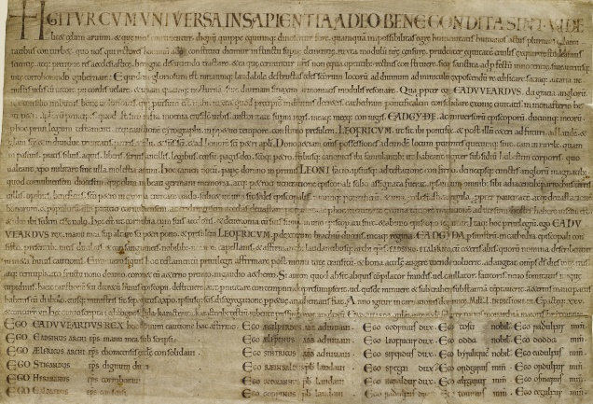

You can keep up with news from around the Cathedral, through the new Cathedral Life newsletter. It comes out every Friday and each week includes a feature on a different item from the Library & Archive collections. https://www.exeter-cathedral.org.uk/newsletter-signup/

Ellie Jones, Cathedral Archivist

Devon & Exeter Institution

Our region revealed: Unlocking the treasures of the Devon and Exeter Institution Illustration Collection

We are delighted to announce the launch of our Collections Explorer website featuring images from the project. Collection highlights include:
- Edward Ashworth’s sketchbooks. Edward Ashworth (1814 – 1896) was an English artist and architect from Devon, considered to be the West Country's leading ecclesiastical architect.
- The Exeter Diocesan Architectural Society. The society was established in 1841 to report on the fabric of the churches of Devon and also to approve designs for new churches. Many leading West Country architects belonged to the Society in the 19th century.
The project has enabled us to develop new ways of engaging with these historic materials and with this in mind we have exciting plans to inspire, share and showcase the collections with workshops, talks, learning and engagement activities.

The images on the Collection Explorer are available for purchase and download via the website and all funds will help the Institution to continue to deliver outstanding public education and essential collection care.

View our Collections Explorer here; https://collectionsexplorer.devonandexeterinstitution.org/

Once again, we would like to thank The Friends of Devon's Archives for your generous support for the project. If you would like to know more about the project please contact Carol Anderson: carolanderson@devonandexeterinstitution.org Carol Anderson, Digitisation Coordinator, Devon and Exeter Institution.

Carol Anderson, Digitisation Coordinator, Devon and Exeter Institution

Brixham Heritage Museum

The Museum re-opened from Tuesday-Friday, 10-1, but will be closing on 30 October until March 2021. Although closed to the public, there will still be people working at the Museum in the interim.

Amanda Bouchier, Administrator

Torquay Museum

The Museum is open and we have a booking system, we are also open for archive enquiries. We can do most requests remotely and supply images and documents from our archives. If you want to visit the Museum you can book your slot either by visiting https://torquay-museum.arttickets.org.uk/ or by telephoning the Museum on 01803 293975 during normal office hours.

We also have a new exhibition which is map based – see article below.

When Soviet Spies Mapped Torbay

In 2017 the Museum was approached by Nathan Allen an employee of a touring exhibitions company called Bespoke Scientific. He produced a copy of a map of Torbay in their company’s possession unlike anything we had ever seen.

The Map had been produced in Russia, in 1976, in the middle of the Cold War and showed Torbay in greater detail than any Ordinance Survey or commercial map that was available. The existence of this map posed so many questions, how did they make it? Who was employed to do this work? Why did they make it, and what was it for? Our immediate thought was that we wanted to exhibit these maps in the Museum and tell the story of how they came into existence.

During the Cold War the Soviet Union embarked on the greatest secret intelligence-gathering operation the world has ever (not) seen, with spy satellites, reconnaissance aircraft and undercover agents gathering information from across the globe. It drew up detailed maps of the great cities of the world: New York, Paris, London… and Torbay! The astonishing detail shown on the maps was useful for spies and policy makers, diplomats and invading armies and potentially occupiers. These maps provided tactical information about Torbay and chilling insights about the best routes for tanks and harbours with deep water for destroyers.

The maps were part of a huge undertaking to record vast areas of the planet at various levels of detail long before Google Earth. After the collapse of the Soviet Union, these top secret documents, some of which are still classified by the Russian Government, were held in military depots throughout the USSR. Those that were held outside Russian controlled territories were gradually traded with the West in exchange for much needed currency. Even today no one who made them will talk with the west about their manufacture and many have not been publically displayed, the Torbay maps will be displayed in the Museum for the first time.

The maps give fascinating detail of how the Soviets viewed Torbay and the UK at the height of the Cold War. Placed in the context of local Civil Defence, the Protect and Survive information campaign and life under the threat of nuclear attack they bring back a world we have so quickly forgotten and remind us how rapidly things can change. They also raise the question, what else do we not know is happening?

The exhibition The Russians Are Coming! Soviet Spies and the Secret Mapping of Torbay is now on and ends on January 2nd 2021, see our website www.torquaymuseum.com Booking is required.

Barry Chandler, Torquay Museum

Tiverton Museum of Mid Devon Life

We’re delighted to have re-opened the museum on Thursday 10th September 2020. This was possible thanks to funding from The National Lottery Heritage Fund which has enabled the museum to safely re-open to visitors. To make the museum COVID secure for our visitors, volunteers and staff we have put a number of measures in place, including limited opening and priority to pre-booked tickets (full details on www.tivertonmuseum.org.uk). There is still plenty to see at the museum and we hope to welcome you back again soon!

Pippa Griffith, Director and Mid Devon Museum Development Officer

Totnes Archives

News from Totnes Archives

Lockdown affected us in line with everyone else and we continue to remain closed to visitors. Totnes Museum is closed until next year. The reason being that neither the Archive or the Museum building can be made safe in respect of recent guidelines.

However Sue and Jill decided that they could effectively work from home and so they have been very busy answering queries about Local and Family History and about Totnes in general. It has been a very busy time.

A chest of Farwell family deeds, wills and papers has been received and the contents have been photographed and sorted.

Extensive Family History requests have resulted in many hours work. One client deposited about 20 years of Family History work with a request that it be sorted and ordered into an easily readable document. Work is still proceeding on that!

Our usual yearly publication “Totnes Review” written mainly by the Archive volunteers
is about to be issued online. The printers were not working during lockdown and shops are only just opening again so it was thought that an online publication was best this year.
It should be out in October.

The last few months have not been easy for anyone but at Totnes Archives work has gone on more or less as usual.

Jill Drysdale

Devon Rural Archives

DRA Update September 2020

After being closed for nearly five months, the DRA reopened in early August, but to ensure the safety of our visitors, staff and volunteers we have made some changes to the way in which we operate. Admission to the Archive is now on an appointment only basis and numbers are strictly limited. We are currently unable to offer open-shelf access to our resources and instead select relevant material for each visitor ahead of their arrival, based on a telephone consultation at the time of booking. In doing so we are able to keep track of items that have been used and ensure they are available (and not quarantined) when they are next required. The booking system is working well, and interest in visiting is high with roughly a two week wait for appointments.

For now, our programme of events and exhibitions remains suspended and we hope we may be able to offer some of our cancelled events next year. In the meantime, we plan to strengthen our online presence with a new website and hope to be able to host some events online in the future.

The Archive is open to the public on a Monday, Tuesday and Thursday between 11am and 3pm (other than Bank Holidays). There is no charge for using the resources, but booking is essential. For more information or to book an appointment please call 01548 830832.

Abi Gray

Editor’s Indulgence …

WHAT’S IN A NAME?
BEATRICE SNOWSTORM COPP

When conducting research at the Devon Heritage Centre it is often the case that something crops up to pique your interest and take you off your intended search to follow a more intriguing path. Such was the name of Beatrice Snowstorm Copp who was baptised on 12 January 1876 at Bishops Nympton, the daughter of Henry and Elizabeth Copp whose address was given as Whitechapel, Bishops Nympton and father’s occupation as Farmer. Her birth registration was in the name of Beatrice Snowstorm C.Copp in the March Quarter of that year for South Molton.

Following her through the subsequent censuses revealed that she was a later addition to the family with older siblings in 1881 given as Bessie (1859), Thomas (1862), Sally (1864), Georgianna (1866), Mary E. (1868), Emily (1870), and George H. (1872) living at Lower Windsford, Bideford. Their father was born in 1826 and mother in 1838.

Baptisms for Beatrice’s siblings revealed that Emily was baptised 17 June 1869, George Henry together with twin Annie were privately baptised 19 October 1871 and William Davey on 11 April 1874. Annie and William Davey were not recorded on the 1881 census and both died as very young babies.

By 1891 Beatrice was listed as a 16 year old domestic with her widowed father and siblings Sallie, Georgie and Henry [George Henry] still living at home at Abbotsham Road, Lower Winsford, and by 1901 she was a cook domestic at the house of George Browse, a tailor’s cutter at 85 Kensington Garden Square, Paddington.

Beatrice married Robert Percy S.Cawsey in the June Quarter 1902 in the Torrington registration district and the 1911 census listed the family at Ladysmith Villa, Barnstaple. Percy’s age was given as 41, a farmer and grazier, born Tawstock. Beatrice was age 35 (married 9 years, 2 children born alive, 2 still living, none died) with sons Leonard age 5 born St Giles, and Bruce age 1, born Barnstaple. Leonard Copp Cawsey’s birth registration was in the June Quarter of 1905 in the Torrington registration district and his death in the September Quarter of 1926 in the Barnstaple registration district at age 21. A birth registration could not be found for a Bruce Cawsey (unless he was actually named Charles Thomas with a birth registration in the Holsworthy district in 1910). A death registration was also not found for either Bruce or Charles Thomas.

Robert Percy Cawsey died in the March Quarter of 1941 in the Barnstaple registration district age 70. Beatrice Snowstorm Copp Cawsey of Haddacott died 18 November 1962 and was buried in the parish of Alverdiscott on 21 November 1962 age 87.

So, what’s in a name? Without the benefit of a purchased birth certificate it is impossible to know for certain whether Beatrice had been born during a snowstorm but the following was found on www.netweather.tv for 1875-76: “Amazingly snowy winter for the UK, especially the South East early on, the first week of December dumped 1-2ft in some places, worst in the South East. March of this month had many snowstorms, and April recorded nearly 2ft of snow in the Midlands! Snowfall was recorded (on a notable scale), in November, December, January, February, March, April, and May!” The person compiling this information wrote “I would regard this winter as very snowy.”

My thanks also to Dr Todd Gray for sending details from Exeter & Plymouth Gazette for Monday 10 January 1876 which refers to the previous Saturday [8 January 1876]:
“Okehampton - SNOWSTORM: This town and neighbourhood were visited on Saturday with a heavy snowstorm, which lasted for several hours. The surrounding hills were completely covered with snow.”

Given that Beatrice’s baptism was 12 January 1876, four days after this snowstorm is likely to be the reason for her unusual Christian name.

Sue Jackson sue.pete.jackson@gmail.com

Contributions to future Newsletters

If you would like to contribute an article to the Newsletter, you would be most welcome. Please do get in touch with the Newsletter editor Sue Jackson via e-mail: sue.pete.jackson@gmail.com

Likewise, if you have any comments to make, please contact me.

Sue Jackson
FoDA Newsletter Editor

